RCEA JOINT EXAMINATION
Kenya Certificate of Secondary Education-KCSE
443/2 - AGRICULUTER PAPER 2
FORM 4 2026. TIME 2 HOURS.
Name………………………………………………………..Index No………………………
ADM No…………………….
School…………………………………………………… Date …………Stream………

INSTRUCTIONS TO CANDIDATES

- Write your name and Admission number in the spaces provided above.
- Answer all the questions in the spaces provided in the question paper
- This paper consists of three sections A, B and C.
- Answer all questions in section A and B
- Answer any Two Questions in Section C in the Spaces Provided.

FOR EXAMINER’S USE ONLY
SECTION | QUESTION | MAXIMUM  SCORE | CANDIDATES SCORE
A | 1-15 | 30
B | 16-19 | 20
C | 20-22 | 40
TOTAL SCORE |  | 90

Section A (30 marks)
Answer all questions in this section in the spaces provided after each question.
- State four reasons for dehorning cattle. (2 marks)
………………………………………………………………………………………………………………………………………………………………………………………………………………………………………………………………………………………………………………………………………………………………………………………………………………………………
- State four harmful effects of keds. (2 marks)
………………………………………………………………………………………………………………………………………………………………………………………………………………………………………………………………………………………………………………………………………………………………………………………………………………………………
- State four components required in preparation of artificial colostrum. (2 marks)
………………………………………………………………………………………………………………………………………………………………………………………………………………………………………………………………………………………………………………………………………………………………………………………………………………………………
- List four maintenance practices carried out on sprayers. (2 marks)
………………………………………………………………………………………………………………………………………………………………………………………………………………………………………………………………………………………………………………………………………………………………………………………………………………………………
- List four materials that are fed to fish. (2 marks)
………………………………………………………………………………………………………………………………………………………………………………………………………………………………………………………………………………………………………………………
- State two reasons for each of the following practices carried out in a brooder;
- Providing litter on the floor (1 mark)
………………………………………………………………………………………………………………………………………………………………………………………………………………
- Maintaining a round brooder board (1 mark)
………………………………………………………………………………………………………………………………………………………………………………………………………………
- List four developmental stages of a tsetse fly. (2 marks)
………………………………………………………………………………………………………………………………………………………………………………………………………………………………………………………………………………………………………………………………………………………………………………………………………………………………
- State four reasons for feeding bees. (2 marks)
………………………………………………………………………………………………………………………………………………………………………………………………………………………………………………………………………………………………………………………………………………………………………………………………………………………………
- State four bloat non chemical treatment methods. (2 marks)
………………………………………………………………………………………………………………………………………………………………………………………………………………………………………………………………………………………………………………………………………………………………………………………………………………………………
- Name four maintenance practices carried out on barbed wire fences. (2 marks)
………………………………………………………………………………………………………………………………………………………………………………………………………………
- State four functions of omasum in the ruminant digestive system (2 marks)
………………………………………………………………………………………………………………………………………………………………………………………………………………………………………………………………………………………………………………………………………………………………………………………………………………………………
- Name four equipment used to administer antihelminitics through the mouth. (2 marks) ………………………………………………………………………………………………………………………………………………………………………………………………………………………………………………………………………………………………………………………………………………………………………………………………………………………………
- List four components of a differential part of the tractor. ( 2 marks)
………………………………………………………………………………………………………………………………………………………………………………………………………………………………………………………………………………………………………………………………………………………………………………………………………………………………
- State four characteristics of Romney marsh breed of sheep. (2 amrks)
………………………………………………………………………………………………………………………………………………………………………………………………………………………………………………………………………………………………………………………………………………………………………………………………………………………………
- State four signs of parturition in sows. (2 marks)
………………………………………………………………………………………………………………………………………………………………………………………………………………………………………………………………………………………………………………………………………………………………………………………………………………………………

SECTION B (20 MARKS)
- The photograph bellow is a livestock identification method, study it and answer the following questions.
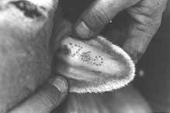
- Identify the method (1 mark)
………………………………………………………………………………………………………(b) Apart from the ear name other two body parts the marks may be made. (2 marks)
………………………………………………………………………………………………………(c) Name two species of livestock in which the method is most suitable (2 marks)
………………………………………………………………………………………………………

- The diagram below illustrates a livestock management practice. Study it and answer the following questions.

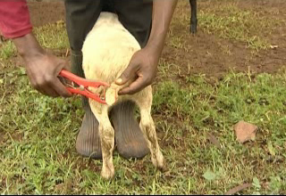

- Identify the practice. (1 mark)

…………………………………………………………………………………………………….
- Name the species in which the practice is carried out. ( 1 mark)

……………………………………………………………………………………………………
- State three reasons for carrying out the practice. (3 marks)
………………………………………………………………………………………………………………………………………………………………………………………………………………………………………………………………………………………………………………………
- The photograph below shows a dairy rearing system. Study it and answer the following questions.

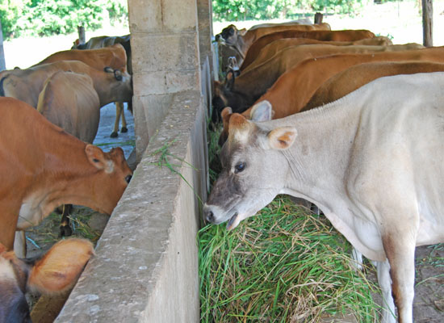
- Identify the system. ( 1marks)

………………………………………………………………………………………
- List two building materials used in construction of the structure. (2 marks)
…………………………………………………………………………………………………………………………………………………………………………………………….
- Name four parts found in the structure. (2 marks)
………………………………………………………………………………………………………………………………………………………………………………………………………………

- Study the diagram of an artificial incubator below and answer questions that follow.
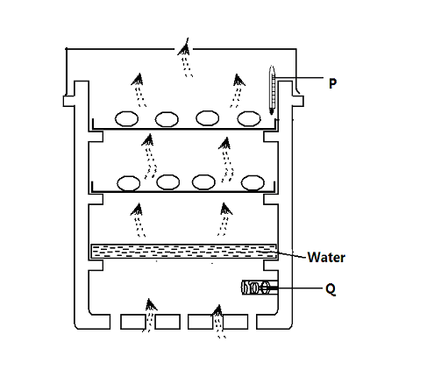
- Identify the parts labeled P and Q (2mks)
P…………………………………………………………………………………………………
Q…………………………………………………………………………………………………
- Why is water provided in the incubator? (1mk)
……………………………………………………………………………………………………
- What other factor not observed in the diagram has been provided? (1mk)
……………………………………………………………………………………………………
- What is the adequate relative humidity in an incubator? (1mk)
……………………………………………………………………………………………………

SECTION C (40 marks)
- (a) Describe fowl typhoid under the following sub headings;
- Causal organism (1 mark)
- Symptoms. (5 marks)
- Control and treatment. (4 marks)

- Describe general characteristics of dairy cattle. (10 marks)

- (a) Describe factors that determine choice of poultry rearing system (10 marks)
(b) State five deficiency symptoms of vitamins in livestock giving their cause in each case (10 marks)
- (a) describe the life cycle of a three host tick (10 marks)
(b) State the rules followed in milking and for each rule give the reason for it to be observed. (10 marks)
………………………………………………………………………………………………………………………………………………………………………………………………………………………………………………………………………………………………………………………………………………………………………………………………………………………………………………………………………………………………………………………………………………………………………………………………………………………………………………………………………………………………………………………………………………………………………………………………………………………………………………………………………………………………………………………………………………………………………………………………………………………………………………………………………………………………………………………………………………………………………………………………………………………………………………………………………………………………………………………………………………………………………………………………………………………………………………………………………………………………………………………………………………………………………………………………………………………………………………………………………………………………………………………………………………………………………………………………………………………………………………………………………………………………………………………………………………………………………………………………………………………………………………………………………………………………………………………………………………………………………………………………………………………………………………………………………………………………………………………………………………………………………………………………………………………………………………………………………………………………………………………………………………………………………………………………………………………………………………………………………………………………………………………………………………………………………………………………………………………………………………………………………………………………………………………

