KABRAS WEST SUB-COUNTY
JOINT EVALUATION TEST (JET)
2026

NAME: …………………………………………………………………………………………

SHOOOL: ………………………………………………….. STREAM: ……………………

ADM NO: ……………………. SIGN: …………………….…. DATE: ……………………

BIOLOGY – PAPER ONE (231/1)

FORM FOUR (4)

Time - 2 Hours

INSTRUCTIONS TO CANDIDATES

1. Write your name, school and admission number in the spaces provided.
2. All questions are compulsory.
3. Answer all the questions in the spaces provided after the questions.
4. Wrong spelling of technical terms shall be penalized.
5. Candidates should check the question paper to ascertain that all pages are printed as indicated and that no question is missing.

MAXIMUM SCORE | CANDIDATE’S SCORE
80

- a) Name the instrument used to measure the level of humidity in the environment during an ecological study. (1mark)
----------------------------------------------------------------------------------------------------------------------------------------------------------------------------------------------------------------
b) Give two reasons why an ecosystem is said to be a self-sustaining unit. (2marks)
------------------------------------------------------------------------------------------------------------------------------------------------------------------------------------------------------------------------------------------------------------------------------------------------------------------------
- (a) Name one defect of the circulatory system in humans. (1 mark)
----------------------------------------------------------------------------------------------------------------------------------------------------------------------------------------------------------------
(b) State three functions of blood other than transport. (3marks)
----------------------------------------------------------------------------------------------------------------------------------------------------------------------------------------------------------------
----------------------------------------------------------------------------------------------------------------------------------------------------------------------------------------------------------------
- Using a microscope, a student counted 55 cells across a field of view whose diameter was 6000µm. Calculate the average length of the cells. Show your working. (2 marks)

- Explain how the following forces contributes to the movement of water up the xylem vessels: (2 marks)
  - (a) Cohesion:
----------------------------------------------------------------------------------------------------------------------------------------------------------------------------------------------------------------
  - (b) Adhesion.
----------------------------------------------------------------------------------------------------------------------------------------------------------------------------------------------------------------
- State the importance of the following features of a respiratory surface. (2mks)
- Being moist.
----------------------------------------------------------------------------------------------------------------------------------------------------------------------------------------------------------------
- Having thin lining.
----------------------------------------------------------------------------------------------------------------------------------------------------------------------------------------------------------------
- Explain why a bony fish dies shortly after being removed from water. (4 marks)
----------------------------------------------------------------------------------------------------------------------------------------------------------------------------------------------------------------
----------------------------------------------------------------------------------------------------------------------------------------------------------------------------------------------------------------
----------------------------------------------------------------------------------------------------------------------------------------------------------------------------------------------------------------
- The following is a reaction that takes place in the human body
Ammonia + Carbon (IV) Oxide Compound Q + Water
- Name the enzyme that catalyzes this process. (1mark)
----------------------------------------------------------------------------------------------------------------------------------------------------------------------------------------------------------------
- Why should Ammonia be converted to Compound Q before being excreted. (2marks)
----------------------------------------------------------------------------------------------------------------------------------------------------------------------------------------------------------------
--------------------------------------------------------------------------------------------------------
- The diagram below represents a set-up that students used in a biological investigation.
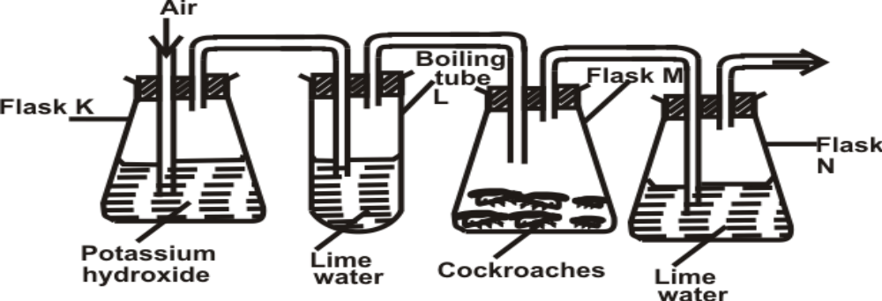
- a) Name the physiological process that was being investigated. (1mark)
--------------------------------------------------------------------------------------------------------
--------------------------------------------------------------------------------------------------------
- b) State the role of potassium hydroxide in flask K. (1 mark)
--------------------------------------------------------------------------------------------------------
--------------------------------------------------------------------------------------------------------

- c) Account for the observation in boiling tube L and flask N. (2 marks)

Boiling tube L

--------------------------------------------------------------------------------------------------------
--------------------------------------------------------------------------------------------------------

Flask N
--------------------------------------------------------------------------------------------------------
--------------------------------------------------------------------------------------------------------
--------------------------------------------------------------------------------------------------------
- Construct two steps in a dichotomous key using one compound leaf and two simple leaves one with a serrated and the other with a smooth margin. (4 marks)

- The following graph shows the relationship between light and amount of bubbles formed in an experiment involving pondweed.
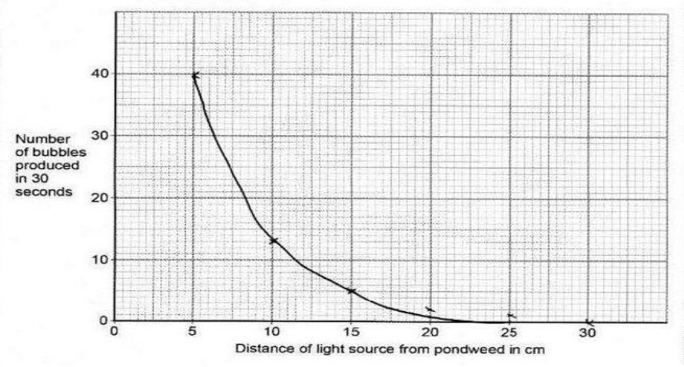
- Name the process responsible for bubble formation. (1mark)
--------------------------------------------------------------------------------------------------------
--------------------------------------------------------------------------------------------------------
- Account for the amount of bubbles formed at 5cm. (3marks)
--------------------------------------------------------------------------------------------------------
--------------------------------------------------------------------------------------------------------

- Explain how the following prevent self-pollination.
(i) Protandry (2 marks)
----------------------------------------------------------------------------------------------------------------------------------------------------------------------------------------------------------------
(ii) Self-sterility (2 marks)
--------------------------------------------------------------------------------------------------------
--------------------------------------------------------------------------------------------------------
- Transport of water is efficient in angiospermaphyta than in gymnospermaphyta, explain. (2marks)
--------------------------------------------------------------------------------------------------------
--------------------------------------------------------------------------------------------------------
--------------------------------------------------------------------------------------------------------
--------------------------------------------------------------------------------------------------------
- How do sunken stomata reduce transpiration. ( 2 marks)
--------------------------------------------------------------------------------------------------------
--------------------------------------------------------------------------------------------------------
--------------------------------------------------------------------------------------------------------
- In a respiratory experiment, a mouse was observed to have inhaled 20cm³ of oxygen and exhaled 19.8cm³ of carbon (IV) oxide in one minute.
- Calculate the respiratory quotient for the activity in the experiment. (2 marks)

(b) Identify the possible food substance consumed by the mouse. (1 mark)
--------------------------------------------------------------------------------------------------------
--------------------------------------------------------------------------------------------------------

(c) State the fate of the excess food named in (b) above in the human body. (2 marks)
--------------------------------------------------------------------------------------------------------
--------------------------------------------------------------------------------------------------------
- Given the following; a glass slide, a cover slip, a pair of forceps, onion leaf, iodine solution and distilled water, describe three steps to be followed before viewing onion cells on a microscope. (3 marks)
--------------------------------------------------------------------------------------------------------
--------------------------------------------------------------------------------------------------------
--------------------------------------------------------------------------------------------------------
--------------------------------------------------------------------------------------------------------
--------------------------------------------------------------------------------------------------------
--------------------------------------------------------------------------------------------------------

- The photograph shown below is of blood from a patient observed under a microscope.
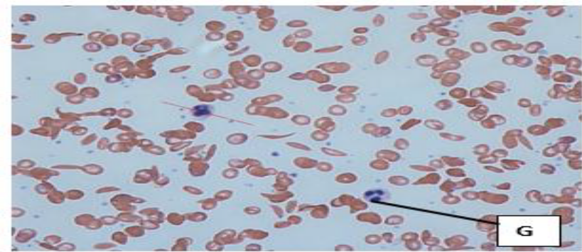
a) State the function of cell G in the human body. (1mark)
--------------------------------------------------------------------------------------------------------
--------------------------------------------------------------------------------------------------------
b) Identify the genetic disorder represented by the photograph shown above. (1mark)
--------------------------------------------------------------------------------------------------------
--------------------------------------------------------------------------------------------------------
c) Using A to represent the normal gene and T to represent the defective gene:
i) Write the genotype of the person with the genetic disorder named in (b). (1mark)
--------------------------------------------------------------------------------------------------------
--------------------------------------------------------------------------------------------------------
ii) Workout the genotypes of offspring obtained from a marriage of two persons with the genetic disorder shown above. (2marks)

iii) Why is there a higher prevalence of the genetic disorder above in malaria-prone areas. (1mark)
--------------------------------------------------------------------------------------------------------
--------------------------------------------------------------------------------------------------------
--------------------------------------------------------------------------------------------------------
- a) State a difference between a housefly’s wing and a bat’s wing (1 mark)
Housefly’s wing Bat’s wing
------------------------------------------ ------------------------------------------------
------------------------------------------ ------------------------------------------------
b) What name is given to structures like the wings in (a) above (1 mark)
--------------------------------------------------------------------------------------------------------
--------------------------------------------------------------------------------------------------------
(c) Name the evidence of evolution that explains the origin of the differences of the wings (1 mark)
--------------------------------------------------------------------------------------------------------
--------------------------------------------------------------------------------------------------------
- . (a)The diagram below represents a stage during cell division.
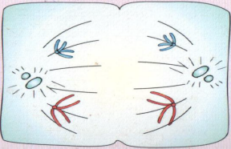 M
i) Identify the stage of cell division (1 mark)
--------------------------------------------------------------------------------------------------------
--------------------------------------------------------------------------------------------------------
ii) Give one reason for your answer (a) (i) above (1 mark)
--------------------------------------------------------------------------------------------------------
--------------------------------------------------------------------------------------------------------
(b) Name the structure labeled M (1 mark)
--------------------------------------------------------------------------------------------------------
--------------------------------------------------------------------------------------------------------
- Explain why all the energy produced by producers does not flow to the tertiary consumers. (2marks)
--------------------------------------------------------------------------------------------------------
--------------------------------------------------------------------------------------------------------
- Tar present in burning tobacco has been found to be carcinogenic leading to lung cancer.
a) Name a plant waste product that can be used in lung cancer therapy. (1mk)
--------------------------------------------------------------------------------------------------------
--------------------------------------------------------------------------------------------------------
b) State two means of lung cancer treatment. (2mks)
--------------------------------------------------------------------------------------------------------
--------------------------------------------------------------------------------------------------------
- Use the section of eye retina shown below to answer questions that follow. 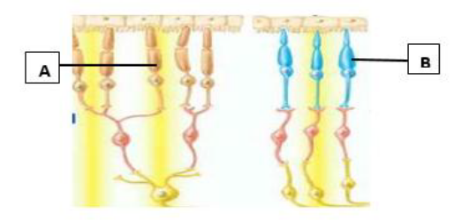
a) What is the survival importance of having both cells A and B in the same eye of an animal? (1mk)
--------------------------------------------------------------------------------------------------------
--------------------------------------------------------------------------------------------------------
b) i) Which letter represents the cell that gives the eye a high visual acuity? (1mk)
--------------------------------------------------------------------------------------------------------
--------------------------------------------------------------------------------------------------------
ii) Give a reason for your answer in b (i). (1mk)
--------------------------------------------------------------------------------------------------------
-------------------------------------------------------------------------------------------------------

- Name the type of response shown by: (3mks)
a) Leaves of Mimosa pudica when they fold after being touched.
--------------------------------------------------------------------------------------------------------
-------------------------------------------------------------------------------------------------------
- Sperms when they swim towards ovum.
--------------------------------------------------------------------------------------------------------
-------------------------------------------------------------------------------------------------------
c) Euglena when they swim towards the source of light.
--------------------------------------------------------------------------------------------------------
-------------------------------------------------------------------------------------------------------
- The diagram below illustrates a germinating seedling.
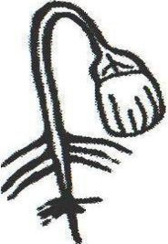
a) Name the type of germination illustrated in the diagram. (1 mark)
--------------------------------------------------------------------------------------------------------
-------------------------------------------------------------------------------------------------------
b) Describe how the type of germination named in (a) above is brought about.(3 marks)
--------------------------------------------------------------------------------------------------------
-------------------------------------------------------------------------------------------------------
--------------------------------------------------------------------------------------------------------
-------------------------------------------------------------------------------------------------------
--------------------------------------------------------------------------------------------------------
- State how each of the following features enhance efficient movement of fish in water. a) Scales. (1 mark)
-------------------------------------------------------------------------------------------------------
--------------------------------------------------------------------------------------------------------
  - b) Body shape (1 mark)
-------------------------------------------------------------------------------------------------------
--------------------------------------------------------------------------------------------------------
  - 25. State three homeostatic roles of the liver. (3 marks)

-------------------------------------------------------------------------------------------------------
--------------------------------------------------------------------------------------------------------
-------------------------------------------------------------------------------------------------------
--------------------------------------------------------------------------------------------------------

