KABRAS WEST SUB-COUNTY
JOINT EVALUATION TEST (JET)
2026

MARKING SCHEME

BIOLOGY – PAPER ONE (231/1)

FORM FOUR (4)

- a) Name the instrument used to measure the level of humidity in the environment during an ecological study. (1mark)
Hygrometer/psychrometer/wet and dry bulb thermometer;
b) Give two reasons why an ecosystem is said to be a self-sustaining unit. (2marks)
Has producers to make food through photosynthesis;
Nutrients are recycled by decomposers;
Energy flows from the sun;
Mark first two.
- (a) Name one defect of the circulatory system in humans. (1 mark)
Hypertension/high blood pressure;
Thrombosis;
Arteriosclerosis;
Varicose veins;
Mark first one.
(b) State three functions of blood other than transport. (3marks)
Regulate osmotic pressure of body fluids;
Distribution of heat in body/ thermoregulation;
Regulate PH value of body fluids;
Body defense;
Prevent excess bleeding;
Mark first three.
- Using a microscope, a student counted 55 cells across a field of view whose diameter was 6000µm. Calculate the average length of the cells. Show your working. (2 marks)

Size of cell = Diameter of field of view
Total number of cells ;
= 6000µm
55 = 109.09µm;

- Explain how the following forces contributes to the movement of water up the xylem vessels: (2 marks)
  - (a) Cohesion:
                - Similar molecules mainly water draws attraction this enhances capillarity;
  - (b) Adhesion.
Attraction between water molecules and the wall of the xylem vessel allow upward movement of water;
- State the importance of the following features of a respiratory surface. (2mks)
- Being moist.
To dissolve (respiratory) gases for faster diffusion;
- Having thin lining.
To reduce/shorten diffusion distance for faster gaseous exchange;
- Explain why a bony fish dies shortly after being removed from water. (4 marks)
When out of water, the gill filaments stick together/collapses; this reduces the surface area compared to when it is in water; Gill filaments are specialized to absorb dissolved oxygen from water, (not gaseous oxygen from air); without water, oxygen cannot diffuse efficiently into the bloodstream;
- The following is a reaction that takes place in the human body
Ammonia + Carbon (IV) Oxide Compound Q + Water
- Name the enzyme that catalyzes this process. (1mark)
Urease/Glutaminase/Arginase/Carbamoyl phosphate synthetase I;
- Why should Ammonia be converted to Compound Q before being excreted. (2marks)
Ammonia is more toxic/ammonia is highly soluble; thus requires a lot of water to excrete;
- The diagram below represents a set-up that students used in a biological investigation.
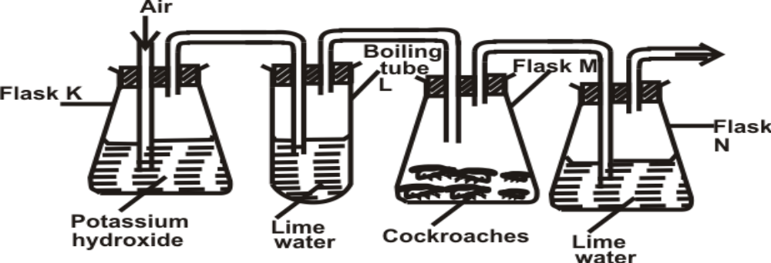
- a) Name the physiological process that was being investigated. (1mark)
Gaseous exchange;
- b) State the role of potassium hydroxide in flask K. (1 mark)
To absorb carbon (IV) oxide from the air;
- c) Account for the observation in boiling tube L and flask N. (2 marks)

Boiling tube L
Lime water remained colourless/clear as air from flask K did not have carbon (IV) oxide;
Flask N
Lime water turned to white precipitate/turbid/cloudy because the cockroaches exhaled carbon (IV) oxide which when bubbled through lime water turns to white precipitate;
- Construct two steps in a dichotomous key using one compound leaf and two simple leaves one with a serrated and the other with a smooth margin. (4 marks)
1(a) Leaf compound …………………………….. Leaf A;
(b) Leaf simple ………………………………… go to 2;
2(a) Leaf margin serrated ........................................ leaf B;
(b) Leaf margin smooth......................................... leaf C;
- The following graph shows the relationship between light and amount of bubbles formed in an experiment involving pondweed.
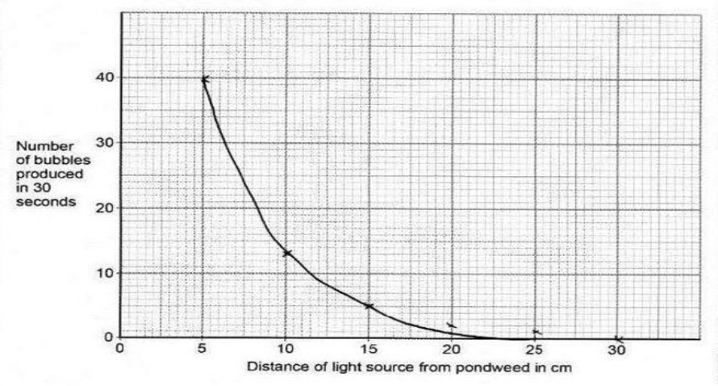
- Name the process responsible for bubble formation. (1mark)
Photosynthesis;
- Account for the amount of bubbles formed at 5cm. (3marks)
High light intensity; leads to a high rate of photosynthesis; hence more oxygen gas is produced as bubbles;
- Explain how the following prevent self-pollination.
(i) Protandry (2 marks)
The male part of the flower/pistil matures and release pollen grains; before stigma/female part of the same flower has matured;
(ii) Self-sterility (2 marks)
Pollen grains from anther cannot germinate on the stigma; of the same flower;
- Transport of water is efficient in angiospermaphyta than in gymnospermaphyta, explain. (2marks)
Gymnospermaphyta have xylem tracheids with perforated cross-walls; while angiospermaphyta have xylem vessels that lack cross-walls;
- How do sunken stomata reduce transpiration. ( 2 marks)
Reduce transpiration by trapping moist air in pits; lowering water vapour gradient/lowering saturation deficit;

- In a respiratory experiment, a mouse was observed to have inhaled 20cm³ of oxygen and exhaled 19.8cm³ of carbon (IV) oxide in one minute.
- Calculate the respiratory quotient for the activity in the experiment. (2 marks)
Respiratory quotient = 𝑣𝑜𝑙𝑢𝑚𝑒 𝑜𝑓 𝑐𝑎𝑟𝑏𝑜𝑛 (𝐼𝑉)𝑑𝑒 𝑟𝑒𝑚𝑜𝑣𝑒𝑑
𝑣𝑜𝑙𝑢𝑚𝑒 𝑜𝑓 𝑜𝑥𝑦𝑔𝑒𝑛 𝑎𝑏𝑠𝑜𝑟𝑏𝑒𝑑
R.Q = 19.8𝑐𝑚³
20𝑐𝑚³ ;
R.Q = 0.99 –̃ 1.0;
(b) Identify the possible food substance consumed by the mouse. (1 mark)
Carbohydrate;
(c) State the fate of the excess food named in (b) above in the human body. (2 marks)
Converted into glycogen and stored for future use;
Converted into neutral fats the stored over vital organs and underneath the skin;
- Given the following; a glass slide, a cover slip, a pair of forceps, onion leaf, iodine solution and distilled water, describe three steps to be followed before viewing onion cells on a microscope. (3 marks)
- Use a pair of forceps to peel a thin (transparent) epidermal layer from (the inner side of) the onion leaf (to allow light to pass through);
- Place it on the glass slide and add a drop of distilled water (to prevent drying);
-Carefully place a cover slip over the specimen (to avoid air bubbles) and add a drop of iodine solution (at the edge of the cover slip);
- The photograph shown below is of blood from a patient observed under a microscope.
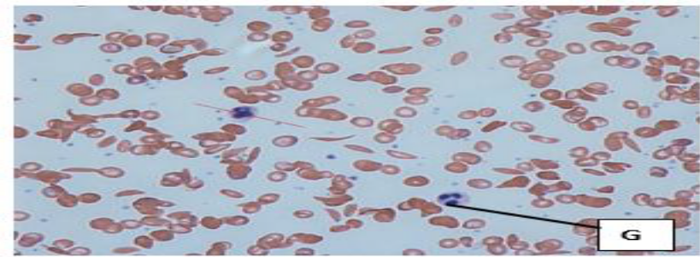
a) State the function of cell G in the human body. (1mark)
Defense against infection;
b) Identify the genetic disorder represented by the photograph shown above. (1mark)
Sickle cell anaemia;
c) Using A to represent the normal gene and T to represent the defective gene:
i) Write the genotype of the person with the genetic disorder named in (b). (1mark)
AT;
ii) Workout the genotypes of offspring obtained from a marriage of two persons with the genetic disorder shown above. (2marks)
AT X AT

A T A T

AA AT AT TT;

1AA, 2AT, 1TT;
iii) Why is there a higher prevalence of the genetic disorder above in malaria-prone areas. (1mark)
Heterozygotes/individuals with sickle-cell trait have malaria resistance; increasing frequency of the gene (as sickle shaped RBCs are less infected by plasmodium); OWTTE
- a) State a difference between a housefly’s wing and a bat’s wing (1 mark)
Housefly’s wing Bat’s wing
Insect wings originate from the exoskeleton; Bat wings originate from endoskeleton;
b) What name is given to structures like the wings in (a) above (1 mark)
Analogous structures;
(c) Name the evidence of evolution that explains the origin of the differences of the wings (1 mark)
Comparative anatomy;
- . (a)The diagram below represents a stage during cell division.
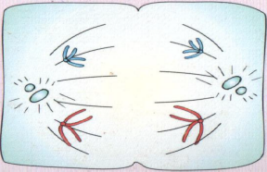 M
i) Identify the stage of cell division (1 mark)
Anaphase/anaphase II;
ii) Give one reason for your answer (a) (i) above (1 mark)
Chromatids separate and move towards the poles;
(b) Name the structure labeled M (1 mark)
Spindle fibers;
- Explain why all the energy produced by producers does not flow to the tertiary consumers. (2marks)
Energy is lost at each trophic level; through respiration/ heat/ excretion/ incomplete consumption;
- Tar present in burning tobacco has been found to be carcinogenic leading to lung cancer.
a) Name a plant waste product that can be used in lung cancer therapy. (1mk)
Cannabis/colchicine;
b) State two means of lung cancer treatment. (2mks)
Surgery to remove tumor;
Radiotherapy;
Chemotherapy;

- Use the section of eye retina shown below to answer questions that follow. 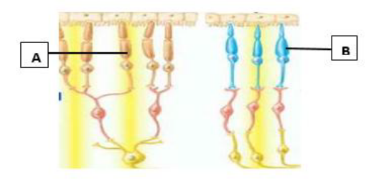
a) What is the survival importance of having both cells A and B in the same eye of an animal? (1mk)
Rods for dim light/night vision; cones for bright light/colour vision;
b) i) Which letter represents the cell that gives the eye a high visual acuity? (1mk)
B;
ii) Give a reason for your answer in b (i). (1mk)
Cones are concentrated in fovea and have one – to – one connection with nerve fibre;

- Name the type of response shown by: (3mks)
a) Leaves of Mimosa pudica when they fold after being touched.
Nictinasty;
- Sperms when they swim towards ovum.
Chemotaxis;
c) Euglena when they swim towards the source of light.
Phototaxis;
- The diagram below illustrates a germinating seedling.
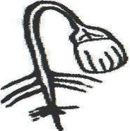
a) Name the type of germination illustrated in the diagram. (1 mark)
Epigeal (germination);
b) Describe how the type of germination named in (a) above is brought about.(3 marks)
The hypocotyl grows very fast and thrusts the cotyledons out of the soil surface; the cotyledons are heavy; and cause the fragile hypocotyl to bend downwards;
- State how each of the following features enhance efficient movement of fish in water. a) Scales. (1 mark)
They overlap facing backwards and have secretion of slippery fluid reducing friction;
  - b) Body shape (1 mark)
They have streamlined shape that eases movement of fish in water by reducing resistance;
  - 25. State three homeostatic roles of the liver. (3 marks)

Regulation of blood glucose levels;
Detoxification of harmful substances;
Conversion of ammonia into urea;

