NAME………………………………………SCHOOL………………INDEX NO…………..

233/1 CANDIDATES SIGN………..
CHEMISTRY DATE…………………
PAPER I
(THEORY)
TIME: 2 HOURS

KABRAS WEST SUBCOUNTY JET 2026
Kenya certificate of secondary education (K.C.S.E)

INSTRUCTIONS TO CANDIDATES
- Write your name and index number in the spaces provided above.
- Sign and write the date of examination in the spaces provided above
- Answer all the questions in the spaces provided
- Mathematical tables and electronic calculators may be used
- All working must be clearly shown where necessary.

FOR EXAMINERS USE ONLY
QUESTION | MAXIMUM SCORE | CANDIDATES SCORE
1 - 29 | 80

This paper consists of 11 printed pages. Candidates should check to ascertain that all pages are printed as indicated and that no questions are missing.

- State and explain the change in mass that occur when the following substances are separately heated in open crucibles.
a) Copper metal (1 $\frac{1}{2}$ marks)
………………………………………………………………………………………………………………………………………………………………………………………………………………
b) Copper (II) nitrate (1 $\frac{1}{2}$ marks)
………………………………………………………………………………………………………………………………………………………………………………………………………………
- (a) State Graham’s law of diffusion (1 mark)
……………………………………………………………………………………………………………………………………………………………………………………………………………… (b) A volume of 120 cm³ of nitrogen gas diffused through a membrane in 40 seconds, how long will 240cm³ of carbon (IV) oxide defuse through the same membrane? (2 marks)

- A reaction of Propane with chlorine gas gave a compound of formula C₃H₇Cl.
- What condition is necessary for the above reaction to take place. (1 mark)
……………………………………………………………………………………………………
- Draw the structural formula of the compound C₃H₇Cl (2 marks)

- Name a gas which is used together with Oxygen in welding. (1 mark)
………………………………………………………………………………………………………………………………………………………………………………………………………………

- Study the table below and answer the questions that follow.
(The letters are not the actual symbols of the elements)
Element | B | C | D | E | F
Atomic number | 18 | 5 | 3 | 5 | 20
Mass number | 40 | 10 | 7 | 11 | 40

(i) Which two letters represent the same elements? Give reason. (2 marks)
……………………………………………………………………………………………………
(ii) Give the number of neutrons in an atom of element D. (Show your working) (1 mark)

- A hydrated salt of copper has the formula CuSO₄.nH2O. About 25g of the salt was heated until all the water evaporated. If the mass of the anhydrous salt is 16.0g, find the value of n. (Cu = 64.0, S = 32.0, O = 16.0, H = 1) (3 marks)

- The table below shows the pH values of the solutions I, II, III and IV
Solution | I | II | III | IV
pH | 2 | 7 | 11 | 14
- Which solution is likely to be that of calcium hydroxide? (1 mark)
………………………………………………………………………………………………………
- Select the solution in which a sample of aluminum oxide is likely to dissolve. Give a reason for your answer. (2 marks)
………………………………………………………………………………………………………………………………………………………………………………………………………………
- Select a pair of solutions that would likely give a pH of 7 when equal volumes are reacted with each other. (1 mark)
………………………………………………………………………………………………………………………………………………………………………………………………………………
- Sodium chloride has a higher melting point than hydrogen chloride, explain. (2 marks) ………………………………………………………………………………………………………….…………………………………………………………………………………………………...

- Study the table below and answer the questions that follow
substance | M.pt ºC | B.pt ºC | Electrical conductivity  in solid state | Electrical conductivity  in molten state
J | 365 | 463 | Nil | Nil
K | 1323 | 2773 | Good | Good
L | 1046 | 1680 | Nil | Good
M | 2156 | 2776 | Nil | Nil
Place J, K, L and M in the appropriate categories from the following:
- Metallic solid ______________________________ (1 mark)
- Covalent network solid ________________________ (1 mark)
- Ionic solid __________________________________ (1 mark)
- Covalent molecular solid_______________________ (1 mark)
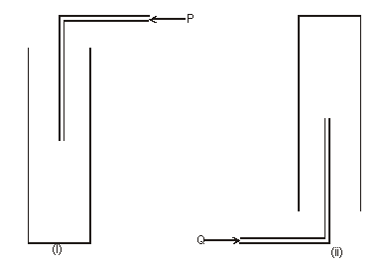
- The diagram below shows how two gases, P and Q were collected.

- Name the two methods used. (2 marks)
(i)..…………………………………………(ii) ……………………………………………....
.
- State properties of P and Q that enable them to be collected through the methods shown.
(2 marks)
……………………………………………………………………………………………………………………………………………………………………………………………………………...
- Study the information in the table below and answer the questions in the table below and answer the questions below the table
Bond | Bond Energy (KJmol⁻¹)
C-H | 414
Cl-Cl | 244
C-Cl | 326
H-Cl | 431
Calculate the enthalpy change of the following reaction
CH₄ _{(g)} + Cl₂ _{(g)} U.V. light CH₃Cl_{(g)}+HCl _{(g)} (3 marks )

- Study the diagram below used to investigate the property of steam on aluminium
Steam
Aluminium powder

- Explain why no gas was collected in the set up above. (1 mark)
………………………………………………………………………………………………………………………………………………………………………………………………………………
- Explain why the reaction between aluminium and steam stops after a short time.
(2 marks)
………………………………………………………………………………………………………………………………………………………………………………………………………………
- A pupil analyzed a commercial vinegar solution by titration and found that 24.5cm³ of 0.09 M sodium hydroxide solution was required for titration of 10 cm³ of vinegar. Calculate the molarity of ethanoic acid CH₃COOH in vinegar. (3 marks)

- The diagram below shows a ‘jiko’ when in use. Study it and answer the questions that follow
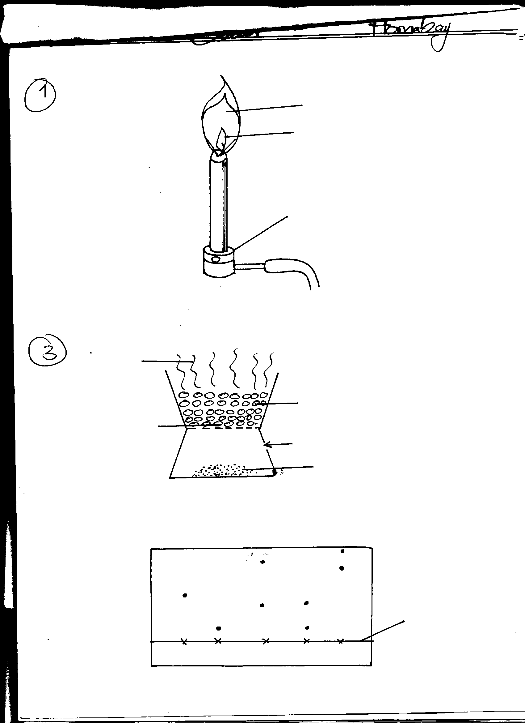
Region B
Region A
Burning charcoal
Air
Ash

(a) Identify the gas formed at region B (1 mark)
………………………………………………………………………………………………………
(b) Using an equation, explain what happens at region A (2 marks)
………………………………………………………………………………………………………………………………………………………………………………………………………………
- Sodium chloride is contaminated with copper (II) oxide. Explain how pure sodium chloride can be obtained from the mixture. (3 marks)
………………………………………………………………………………………………………………………………………………………………………………………………………………………………………………………………………………………………………………………………………………………………………………………………………………………………
………………………………………………………………………………………………………………………………………………………………………………………………………………
- The table below gives three experiments on the reaction of excess sulphuric (VI) acid and 0.5g of zinc done under different conditions. In each the volume of gas was recorded at different time intervals.
Experiment | Form of zinc | Sulphuric (VI) acid solution
I | Powder | 0.8M
II | Powder | 1.0M
III | Granules | 0.8M
On the axis below, draw and label the three curves that could be obtained from such results.
(3 marks)
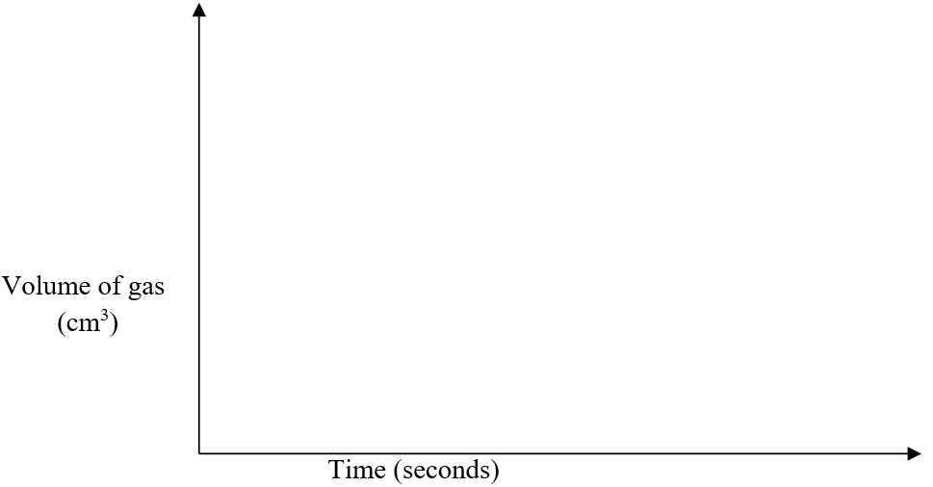
- The set-up of apparatus below used to prepare sulphur (VI) oxide:
Solid SO₃
Ice
Dry gas M
Dry gas N
Catalyst X
Drying agent Y
Solid SO₃
Ice
Dry gas M
Dry gas N
Catalyst X
Drying agent Y

(i) Name Gas N………………………… and Gas M………………………….. (1 mark)
(ii) Catalyst X …………………………………………………………………... (1 mark)
(iii) Why is it necessary to use drying agent Y? (1 mark) ………………………………………………………………………………………………………
- State and explain the observation made when chlorine gas is bubbled into potassium iodide solution. (2 marks)
………………………………………………………………………………………………………………………………………………………………………………………………………………………………………………………………………………………………………………………
- The diagram below shows an arrangement of electrons in Aluminium chloride dimer.
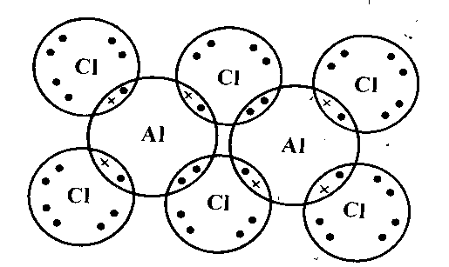
(i) Write down the formula of the above molecule. (1 mark)
……………………………………………………………………………………………………
(ii) On the diagram, indicate using an arrow the dative bond. (1 mark)

- When Magnesium metal is burnt in air, it reacts with both oxygen and nitrogen gases giving a white solid with black specs. Write two equations for the reactions that take place. (2 marks)
……………………………………………………………………………………………………
……………………………………………………………………………………………………
- Below is a representation of an electrochemical cell.
Pb_{(s)}|Pb²⁺_{(aq)}||Ag⁺_{(aq)}|Ag_{(s)}

- What does || represent? (1 mark)
……………………………………………………………………………………………………
- Given the following:
Eᶿ (volts)
Pb²⁺_{(aq)} + 2e⁻ Pb_{(s)} -0.13

Ag⁺_{(aq)} + e⁻ Ag_{(s)} +0.80

Calculate the E.M.F of the electrochemical cell (2 marks)
……………………………………………………………………………………………………
- When hot concentrated nitric (V) acid is added to sulphur, a red – brown gas and a colourless liquid are formed.
(i) Write an equation for the reaction. (1 mark)
……………………………………………………………………………………………………
……………………………………………………………………………………………………
(ii) Identify the oxidizing agent in the reaction above. (1 mark)
……………………………………………………………………………………………………
……………………………………………………………………………………………………
(iii) State one environmental hazard of the nitrogen compounds. (1 mark)
……………………………………………………………………………………………………
- Draw the dot (.) and cross (x) structure of:

- Carbon (II) oxide - CO (2 marks)

- Ammonium ion - NH₄⁺ (2 marks)

- Using sodium hydroxide solution, describe a chemical test that can be used to distinguish between copper (II) ions and iron (II) ions. (3 marks)
………………………………………………………………………………………………………
………………………………………………………………………………………………………
………………………………………………………………………………………………………
………………………………………………………………………………………………………………………………………………………………………………………………………………
- State and explain what would be observed if concentrated sulphuric (VI) acid is added to:
(a) Sugar crystals (1 ½ marks)
………………………………………………………………………………………………………………………………………………………………………………………………………………………………………………………………………………………………………………………
(b) Copper (II) sulphate crystals (1 ½ marks)
………………………………………………………………………………………………………………………………………………………………………………………………………………………………………………………………………………………………………………………
- When 100 cm³ of 0.5 M sulphuric acid solution, H₂SO₄, react with 100 cm³ of 1 M sodium hydroxide solution, NaOH, the temperature rises by 6.85 Kelvins.
(Density = 1.0g/cm³, specific heat capacity = 4.2kJkg⁻¹K⁻¹)
Calculate the molar heat of neutralization described by the equation: (3 marks)
H₂SO_{4(aq)} + 2NaOH_{(aq)} → Na₂SO_{4(aq)} + 2H₂O_{(l)}

- Filtration is carried out in the apparatus shown
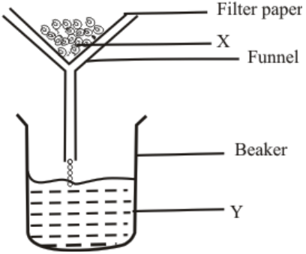
- Name X ……………………………………………………………………… ($\frac{1}{2}$ mark)

- State one property that makes it possible to separate mixtures using filtration. ($\frac{1}{2}$ mark)
……………………………………………………………………………………………………..
- Calculate the oxidation numbers of sulphur in the following species: (3 marks)
- SO₃²⁻

- SO₃

- S₂O₃²⁻

