Name.............................................................................................................AdmNo.......................
Index No.................................Candidate’s sign...........................Date…………………..……….
233/2
CHEMISTRY
PAPER 2
2 HRS

KABRAS WEST SUB-COUNTY
JOINT EXAM 2026
Kenya Certificate of Secondary Education (K.C.S.E.)

INSTRUCTIONS TO CANDIDATES
- Write your name and index number in the spaces provided.
- Answer all questions in the spaces provided
- KNEC mathematical tables and silent electronic calculators may be used for calculations.
- All workings must be clearly shown where necessary.
- Candidates should check the question paper to ascertain all the pages are printed as indicated and no questions are missing.
For Examiners Use Only
Questions | Maximum Score | Score
1 | 11
2 | 11
3 | 11
4 | 11
5 | 12
6 | 15
7 | 9
TOTAL | 80
This paper consists of 12 printed pages. Candidates should check the question paper to ascertain that all pages are printed as indicated and that no pages are missing.

- Wakhisi set-up the experiment as shown below to collect a gas. The wet sand was heated before heating zinc granules.
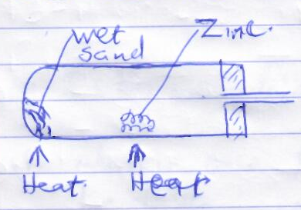

- Complete the diagram for the laboratory preparation of the dry gas. (3mks)
- Why was it necessary to heat the wet sand before heating zinc granules? (1mk)
..............................................................................................................................................................................................................................................................................................
- Write an equation for the reaction in the above set-up. (1mk)
............................................................................................................................................................................................................................................................................................
- State the observation made in the above set-up during the experiment. (1mk)
................................................................................................................................................................................................................................................................................................
................................................................................................................................................
- The gas produced in the above set-up burns in air to form an oxide. Write an equation for the reaction. (1mk)
...............................................................................................................................................................................................................................................................................................
- Sodium hydroxide can be prepared by the following methods, I and II.
- Sodium metal Sodium hydroxide + hydrogen
........................................................................................................................................................................................................................................................................
Process A
- Brine Sodium hydroxide _ Hydrogen + chlorine
- Name one precaution that needs to be taken in method I (1mk)
...........................................................................................................

- Give the name of process A. (1mk)
.........................................................................................................
- Give two industrial uses of:-
- Chlorine. (1mk)
.......................................................................................................................................................................................................................
- Hydrogen. (1mk)
.....................................................................................................................................................................................................................
- The following is a summary of reactions involving nitrogen. Study it and answer the questions below
H_{2(g)}
- 2

6 3 O_{2(g)}

water, 25⁰c O_{2(g)}
5 4
NH_{3(G)}
Nitrogen
Air
A
B
C
Heat
7
Gas E
D

- The process labelled (1) is usually carried out at industrial scales. What process is it? (1mk)
...................................................................................................................................
- Name the substances indicated by the following labels. (4mks)
- A .......................................................................
- B .......................................................................
- D ......................................................................
- E .......................................................................
- Write the equation for the reactions taking place at steps 1 and 2?
1 ................................................................................... (1mk)
2 ................................................................................. (1mk)

- State one application of C apart from any shown in the summary above. (1mk)
....................................................................................................................................................................................................................................................................
- Write an equation for the reaction in step 7. (1mk)
.....................................................................................................................................................................................................................................................................
- Describe a chemical test that can be used to differentiate gas E and Oxygen gas?
(2mks)
..........................................................................................................................................................................................................................................................................................................................................................................................................
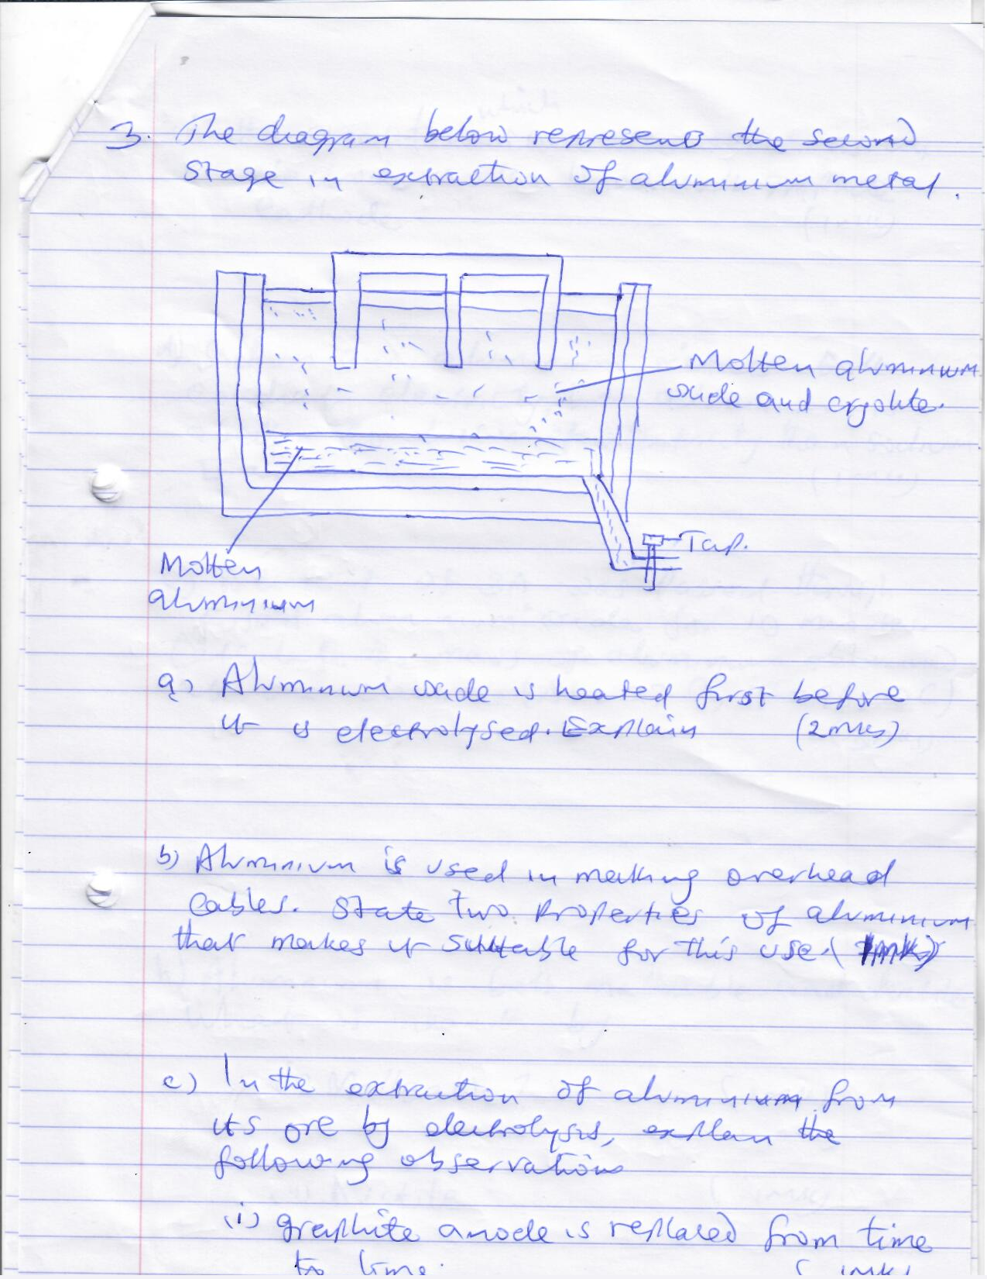
- The diagram below represents the second stage in extraction of aluminium metal

- Aluminium oxide is heated first before it is electrolyzed. Explain. (2mks)
...............................................................................................................................................................................................................................................................................................................................................................................................................................................
- Aluminium is used in making overhead cables. State two properties of aluminium that makes it suitable for this use. (1mk)
...........................................................................................................................................................................................................................................................................................
- In the extraction of aluminium from its ore by electrolysis, explain the following observations.
- graphite anode is replaced from time to time. (1mk)
........................................................................................................................................................................................................................................................................
- the steel tank which can also serve as an electrode is also lined with graphite cathode.
(1mk)
......................................................................................................................................................................................................................................................................
- Sodium and aluminium metals both conduct electricity; but aluminium is a better conductor of electricity than sodium. Explain. (1mk)
...........................................................................................................................................................................................................................................................................................
- A current of 3A was passed through fused aluminium oxide for 10 minutes. Calculate the mass of aluminium obtained at one electrode (Al = 27.0, IF = 96500C) (3mks)

- Aluminium is both malleable and ductile. What is meant by;
- malleable? (1mk)
......................................................................................................................................................................................................................................................................
- ductile (1mk)
........................................................................................................................................................................................................................................................................

- 50cm³ of 2M sodium hydroxide solution were each placed in an insulate beaker, 20cm³ of hydrochloric acid was added to one of the beaker and the heat change was calculated. The experiment was repeated with other sets of hydrochloric acid. The result was recorded in the table below.
Volume of NaOH (cm³) | 50 | 50 | 50 | 50 | 50 | 50 | 50
Volume of HCl (cm³) | 20 | 40 | 60 | 80 | 100 | 120 | 140
Heat change evolved (kJ) | 1.1 | 2.2 | 3.4 | 4.5 | 5.6 | 5.6 | 56

a) Plot a graph of heat change against volume of hydrochloric acid. (3mks)
b) From your graph, determine the volume of hydrochloric acid required to completely neutralize 50cm³ of 2M sodium hydroxide. (1mk)

c) What is the concentration in moles per litre of hydrochloric acid? (2mks)

d) Calculate the molar heat of neutralization for the reaction. (3mks)

e) Sketch an energy level diagram for this reaction. (2mks)

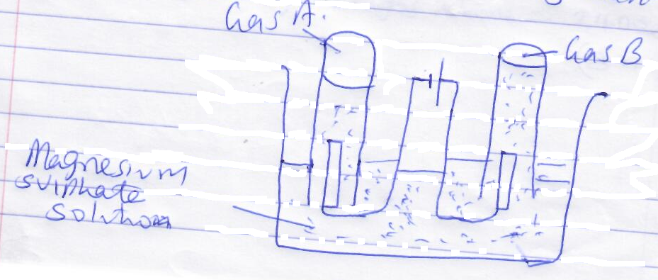
- The set-up below was used to electrolyze aqueous magnesium sulphate using inert electrodes.

- Name a suitable pair of electrodes for this experiment. (1mk)
.............................................................................................................................................
- Identify the anions and cations in the solution. (1mk)
..............................................................................................................................................................................................................................................................................................
- On the diagram, label the cathode. (1mk)
- Write ionic equation for the reaction at the anode. (1mk)
...............................................................................................................................................................................................................................................................................................
- Explain the change that occurred to the concentration of magnesium sulphate solution during the experiment. (2mks)
.............................................................................................................................................................................................................................................................................................................................................................................................................................................
- During electrolysis, a current of 2A was passed through the solution for 4 hours. Calculate the volume of the gas produced at the anode. (If = 96500c, molar gas volume = 24000cm³ (3mks)

- One of the uses of electrolysis is electroplating. What is meant by electroplating?
............................................................................................................................................................................................................................................................................................
- Give two reasons why electroplating is necessary. (2mks)
...............................................................................................................................................................................................................................................................................................................................................................................................................................................

- (a) Study the information in the table below and answer the questions that follow
Number of carbon atoms per molecule | Relative molecular mass of hydrogen
2 | 28
3 | 42
4 | 56
- Write the general formula of the hydrocarbons in the table below. (1mk)
.............................................................................................................................................................................................................................................................................................
- Predict the relative molecular mass of hydrocarbon with 5 carbon atoms.
................................................................................................................................................................................................................................................................................
- Determine the molecular formula of the hydrocarbon in (ii) and draw its structural formula (2mks)

(b) Study the structural formula below and answer the questions that follow.
- CH₃CH₂COOH
- CH₃CH₂CH₂CH₂OH
- Give the systematic name of each compound. (1mk)
........................................................................................................................................
- Write the molecular formula of each compound. (1mk)
.................................................................................................................................................................................................................................................................................
- How does the boiling point of I compare to that of II? (1mk)
...................................................................................................................................................................................................................................................................................
- A gas J is bubbled into concentrated sulphuric (vi) acid. Water is added to the mixture then boiled to yield compound II. Name gas J (2mk)
.....................................................................................................................................
- Draw the structural formula of the compound immediately after compound I in the homologous series. (1mk)

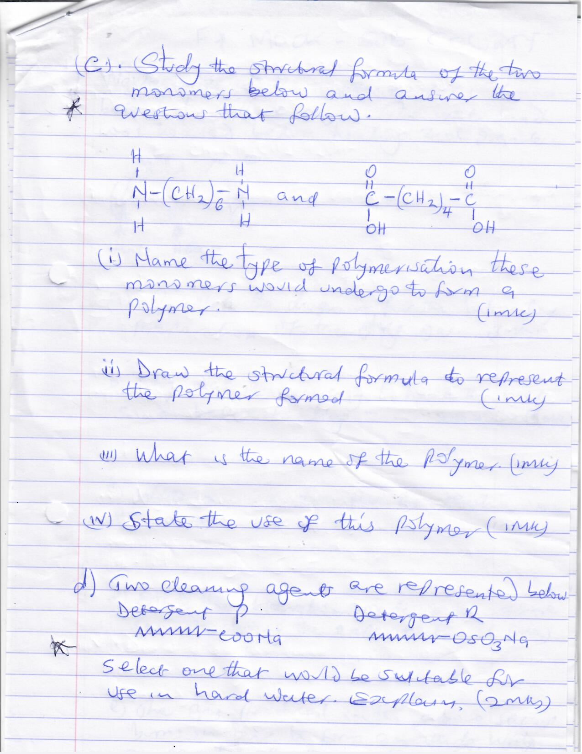
(c) Study the structural formula of the two monomers below and answer the questions that follow.

- Name the type of polymerization these monomers would undergo to form a polymer. (1mk)
..........................................................................................................................................

- Draw the structural formula to represent the polymer formed. (1mk)

- What is the name of the polymer (1mk)
........................................................................................................................................
- State the use of this polymer. (1mk)
..................................................................................................................................................................................................................................................................................
(d) Two cleaning agent are represented below
Detergent p Detergent R

Select one that would be suitable for use in hard water. Explain. (2mks)
...................................................................................................................................................................................................................................................................................................................................................................................................................................................................................
- Use the information below to answer the questions that follow. The letters do not represent the actual symbols of the element.
Element | Ionization energy in kJ
Element | 1st | 2nd | 3rd | 4th
V | 320 | 580 | 4900 | 7200
W | 430 | 4300 | 6200 | 8300
X | 600 | 1050 | 1450 | 16000
Y | 7000 | 9000 | 10500 | 14000
Z | 200 | 420 | 5200 | 6600
- Name two elements that can be found in the same group. Explain. (2mks)
....................................................................................................................................................................................................................................................................................
- To which group do element W belong? Explain (2mks)
............................................................................................................................................................................................................................................................................................................................................................................................................................
- Element Y is found to be in group IV. Write the formula when it reacts with oxygen gas. (1mk)
..................................................................................................................................................................................................................................................................................
- Which of the two elements named in (i) above is more reactive? Explain. (2mks)
...........................................................................................................................................................................................................................................................................................................................................................................................................................
- Which of the five elements in the table above is the best conductor of electricity? Explain. (2mks)
.......................................................................................................................................................................................................................................................................................................................................................................................................................................................................................................................................................................

