Name............................................................................................................ ADM NO............................
School............................................................................................Candidate’s Sign................................
Class ......................................................................Date..........................................

312/1
Geography
Paper 1
Time: 2hrs 45 minutes

KABRAS WEST JOINT EVALUATION TEST
JULY 2026
FORM FOUR EXAM
Kenya Certificate of Secondary Education (KCSE)

INSTRUCTIONS TO CANDIDATES
- Write your name, admission number and school in the spaces provided.
- Answer all questions in the spaces provided
- Answer all the questions in section A, question 6 and any other two questions from section B.
- Candidates should check the question paper to ascertain that all pages are printed as indicated and no questions are missing.
- All answers must be written in English.

FOR EXAMINERS USE ONLY
Question | Max Score | Candidate Score
Section A  Question 6  Option 1  Option 2  Total | 25  25  25  25  100
SECTION A
ANSWER ALL QUESTIONS
1. a) Name two branches of geography. (2 marks)
b) Give three reasons why it is important to study geography. (3 marks)

2. a) What is solar insolation? (2 marks)
b) Outline three importance of moisture in the atmosphere. (3 marks)

3. a) State two effects of the rotation of the earth on its axis. (2 marks)
b) The local time at manual 60° W is 11.30 am. What is the time in Nairobi 37° E? (3 Marks)

4. a) Name two temperate grasslands. (2 marks)
b) Give three uses of Savannah grasslands. (3 marks)

5. a) Name the two types of waves experienced in the coastal area. (2 marks)
b) List three coastal features which result from wave deposition. (3 marks)

SECTION B

ANSWERS QUESTION 6 AND ANY OTHER 2 QUESTIONS
Study the map of Kipkabus 1:50000 (sheet 104/4) provided and answer the following questions.
6. a. (i) what type of map is Kipkabus? (1 mark)
(ii) Give two uses of Kipkabus map. (2 marks)
(iii) Give two marginal information on the map. (2 marks)

b. (i) What is the latitude and longitude of the air photo principal in grid square 9737? (2 marks)
(ii) Name two human features in grid square 8232. (2 marks)

c. Draw a rectangle 12cm by 8cm to present the area bounded by easting 80 and 86 and northing 30 and 34. On the rectangle mark and name the following;
(i) Dry weather road
(ii) Waterhole
(iii) Air photo principal 68
(iv) Forest
d. Describe the relief of the area covered by the map. (5 marks)
e. Citing evidence, give two social services offered in the area covered by the map. (4 marks)

7. a) (i) Name two examples of extrusive igneous rocks. (2 marks)
(ii) Describe the following characteristics of minerals;
- Cleavage (2 marks)
- Lustre (2 marks)
b) Describe the following processes of formation of metamorphic rocks
i) Dynamic metamorphism (4 marks)
ii) Thermal metamorphism (4 marks)
c) Explain three significance of rocks to the economy of Kenya. (6 marks)
d) You are planning to carry out a field study on rocks within the local environment.
(i) Identify two items that you will carry during the study (2 marks)
(ii) State three problems you are likely to encounter (3 marks)

8. a. (i) Define the term folding. (2 marks)
(ii) List two causes of the endogenic processes (2 marks)
b. (i) Apart from Fold Mountains, name three features formed through folding (3 marks)
(ii) Identify three fold mountains formed in the Alpine Orogeny. (3 marks)
c. With the aid of labelled diagrams, describe how Fold Mountains are formed. (7 marks)
d. Explain the effects of folding on physical environment. (8 marks)

9. a. (i) What are tides? (2 marks)
(ii) Give three factors that influence wave deposition. (3 marks)
b. (i) Explain the following processes of wave erosion along the coast. (2 marks)
(ii) Hydraulic action (2 marks)
(iii) Corrosion (2 marks)
c. Describe the formation of the following coastal features.
i) Stack (5 marks)
ii) Spit (4 marks
d. You are planning to carry out a field study along the coast of Kenya.
(i) State four preparations that you will make for the study. (4 marks)
(ii) Name three emerged highland features you are likely to identify. (3 marks)

10. a. (i) Name two major deserts found in Africa. (2 marks)
The diagram below represents features resulting from wind erosion in a desert. Use it to answer question a (ii)
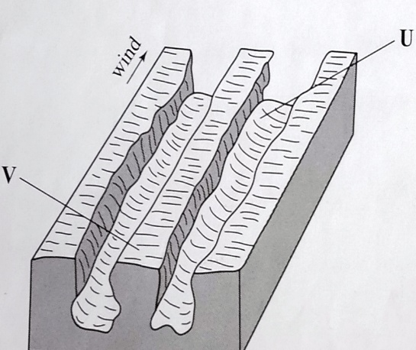

(ii) Name the features marked U and V. (2 marks)
b. Describe the three processes through which wind transports its load. (6 marks)
c. Using a well labelled diagram, describe how a barchans is formed. (7 marks)
d. Explain four ways in which desert features are of significance to human activities. (8 marks)

THIS IS THE LAST PAGE.

