Name............................................................................................................ ADM NO............................
School............................................................................................Candidate’s Sign................................
Class ......................................................................Date..........................................

312/1
Geography
Paper 1
Time: 2hrs 45 minutes

KABRAS WEST JOINT EVALUATION TEST
JULY 2026
FORM FOUR EXAM
Kenya Certificate of Secondary Education (KCSE)
MARKING SCHEME
INSTRUCTIONS TO CANDIDATES
- Write your name, admission number and school in the spaces provided.
- Answer all questions in the spaces provided
- Answer all the questions in section A, question 6 and any other two questions from section B.
- Candidates should check the question paper to ascertain that all pages are printed as indicated and no questions are missing.
- All answers must be written in English.

FOR EXAMINERS USE ONLY
Question | Max Score | Candidate Score
Section A  Question 6  Option 1  Option 2  Total | 25  25  25  25  100
SECTION A
ANSWER ALL QUESTIONS
1. a) Name two branches of geography. (2 marks)
- Physical geography
- Human geography
- Practical geography
b) Give three reasons why it is important to study geography. (3 marks)
- Geography is a career subject it provides a firm foundation for advanced studies in specialized fields like engineering , remote sensing, urban planning etc.
- Study of geography enables one to acquire basic skills and knowledge which contributes to local, regional and national development.
- Through the study of fieldwork, geography teaches one on how to manage time properly by drawing a time schedule and sticking to it.
- Geography focuses on physical study of the earth. We are therefore able to learn and explain the origin of the earth and solar system.
- Geography enables the learners to understand and appreciate different environmental influences at work on different societies.
- Geography creates awareness in the people on the significance of management and conservation of the environment.
2. a) What is solar insolation? (2 marks)
- Solar insolation is the amount of sunshine reaching the surface of the earth.
b) Outline three importance of moisture in the atmosphere. (3 marks)
- Source of precipitation, especially rain.
- Regulating temperature on the earth’s surface.
- Influencing weather conditions.
3. a) State two effects of the rotation of the earth on its axis. (2 marks)
- Causes day and night.
- Causes deflection of ocean currents/winds
- Causes falling and rising of the ocean tides
- Causes difference of 1 hour between 15° meridian
b) The local time at manual 60° W is 11.30 am. What is the time in Nairobi 37° E? (3 Marks)
Difference in degrees 60° + 37° = 97°
97° x 4 = 388 minutes
1 hr = 60 minutes. Thus, 388 ÷ 60 = 6 hours 28 minutes
Nairobi is 6 hours and 28 minutes East of manual; the time is 11.30am + 6 hours 28 minutes
= 17:58hours or 5:58pm.
4. a) Name two temperate grasslands. 2 marks)
- Veldt of South Africa
- Pampas of Argentina
- Prairies of Canada
- Downs of Austria and New Zealand
- Steppes of Eurasia
b) Give three uses of Savannah grasslands. (3 marks)
- The grass provides pasture for grazing for livestock
- The grass increases humus in the soil making it suitable for cereal farming
- The vegetation acts as soil cover thus reducing soil erosion
- The savannah grasslands are habitat for some wild game which are tourist attractions.
5. a) Name the two types of waves experienced in the coastal area. (2 marks)
- Constructive waves
- Destructive waves
b) List three coastal features which result from wave deposition. (3 marks)
- Beaches
- Spits
- Mudflats
- Tombolo
- Cuspate Forelands
- Dune-Belts
- Bars
- Salt Marshes

SECTION B

ANSWERS QUESTION 6 AND ANY OTHER 2 QUESTIONS
Study the map of Kipkabus 1:50000 (sheet 104/4) provided and answer the following questions.
6. a. (i) what type of map is Kipkabus? (1 mark)
- Topographical map
(ii) Give two uses of Kipkabus map. (2 marks)
- To calculate area of a place
- To calculate distance
- To locate features
- Planning for an area
- Used to find direction
(iii) Give two marginal information on the map. (2 marks)
- Map name/sheet title
- Grid system numbers
- Scales
- Compass direction
- Latitudes and longitudes
- Frame
- Index to adjoining sheet
- Key
b. (i) What is the latitude and longitude of the air photo principal in grid square 9737? (2 marks)
latitude 0° 20° N and longitude 35° 40° E
(ii) Name two human features in grid square 8232. (2 marks)
- School
- Dam/artificial lake/reservoir
- Roads
- Bridge
- Built-up areas
c. Draw a rectangle 12cm by 8cm to represent the area bounded by easting 80 and 86 and northing 30 and 34. On the rectangle mark and name the following;
(i) Dry weather road
(ii) Waterhole
(iii) Air photo principal 68
(iv) Forest

Sketch on the grid below:

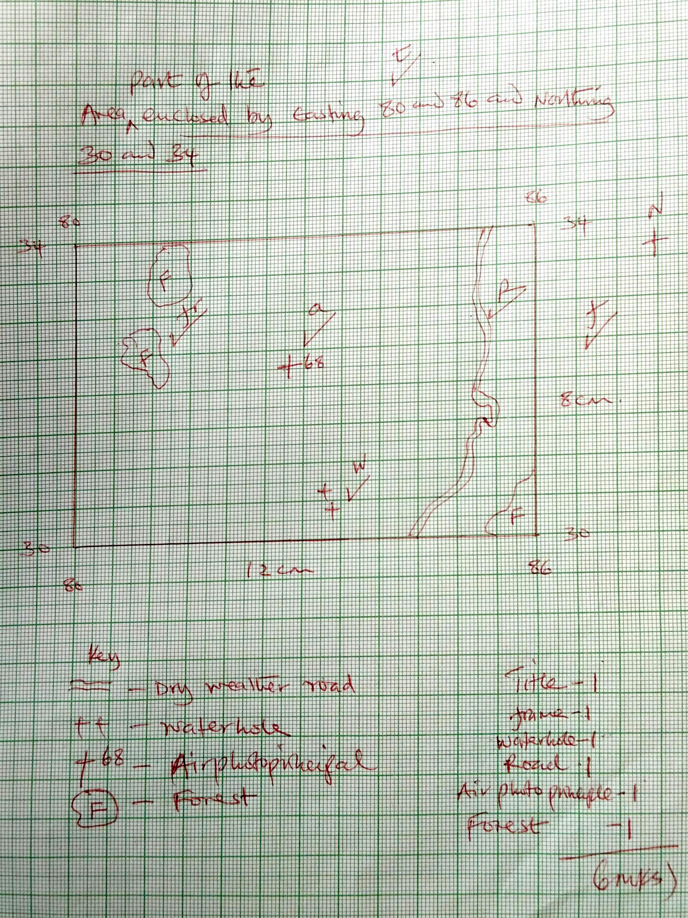

d. Describe the relief of the area covered by the map. (5 marks)
- There is an escarpment in the central part of the area covered by the map
- The area slopes from west to east
- The western part of the area covered by the map is flat evidenced by seasonal swamps
- There are numerous valleys occupied by rivers
- The highest point is 2640 metres
- There are numerous ridges on the Keiyo escarpment
- There are several saddles/cols on the escarpment e.g in grid square 9433

e. Citing evidence, give two social services offered in the area covered by the map. (4 marks)
SOCIAL ACTIVITY | EVIDENCE
Education  Health  Administration | Schools  Dispensary  DC’s office

7. a) (i) Name two examples of extrusive igneous rocks. (2 marks)
- Basalts
- Pumice
- Tuff
- Obsidian
- Andesite
- Rhyolite
- Tephra
- Phonolite
- Trachyte
- Scoria
(ii) Describe the following characteristics of minerals;
- Cleavage (2 marks)
Minerals have patterns in which they split/divide/break into thin layers while others break along layers
- Lustre (2 marks)
Minerals differ in their brightness depending on the nature of their reflective surfaces (smooth surfaces are shiny whereas rough surfaces are dull)
b) Describe the following processes of formation of metamorphic rocks
i) Dynamic metamorphism (4 marks)
- Original rock is subjected to intense pressure that is caused by compressional force when crustal plates collide.
- The great pressure alters the mineral line in the rock structure
- The rock changes physical appearance and characteristics forming new rocks
ii) Thermal metamorphism (4 marks)
Rocks are subjected to intense heat. Heat may be due to rocks buried at greater depth due to contact with magma. The hot magma melts the minerals of the original rock, they cool and solidify to form a totally different rock.
c) Explain three significance of rocks to the economy of Kenya. (6 marks)
- Some rocks in Kenya highlands weather to form deep fertile volcanic soils that supports agriculture
- Some rocks such like limestone are used to manufacture cement, hence promoting building and construction industries
- Some rocks form underground water reservoirs to provide water for domestic use/irrigation
- Some rocks such as Kit Mikai attract tourist hence earning foreign exchange
- Some rocks such as gravel are exploited for building and construction material
- Some rocks such as Kisii soap stone are used to curve artefacts that are sold to generate revenue
- Some serves as a source of income and employment when extracted and sold.
- Some serve as a source of income and employment when extracted and sold.

d) You are planning to carry out a field study on rocks within the local environment.
(i) Identify two items that you will carry during the study (2 marks)
- A fork jembe
- Magnifying lens
- Rock hammer
- Geological map
- Route map
- Spade
- Biodegradable bags
- Eco-friendly bags
(ii) State three problems you are likely to encounter (3 marks)
- Fatigue due to difficult terrain
- Unfavourable weather conditions such as heavy rainfall, extreme high temperatures, which may interfere with study
- Difficult in breaking some rocks
- Accident may occur while handling delicate equipment/walking on difficult terrain
- Difficult in identifying some rocks
- Attack by wild animals
- Some areas may be in remote areas with few vehicles
8. a. (i) Define the term folding. (2 marks)
- Folding is the bending of the crustal rocks when subjected to strong compressional forces.
(ii) List two causes of the endogenic processes (2 marks)
- Compressional forces
- Tensional forces
- Shear forces
b. (i) Apart from Fold Mountains, name three features formed through folding (3 marks)
- Intermontane plateaus and basins
- Escarpments
- Synclinal valleys
- Rolling plain
(ii) Identify three fold mountains formed in the Alpine Orogeny. (3 marks)
- Rockies
- Alps
- Atlas
- Andes
c. With the aid of labelled diagrams, describe how Fold Mountains are formed. (7 marks)
- Extensive shallow depressions called geosynclines develop on the earth’s surface.
- Prolonged and extensive erosion occurs on the surrounding landmasses.
- Running water carries the eroded materials/sediments and deposits them in the geosynclines forming thick layers.
- Weight of the sediments leads to further subsidence of the geosynclines, accumulation of more sediments, triggering off compressional forces, which compress the sediments into folds.
- The folded layers of sediments in the geosynclines are thrust upwards to form Fold Mountain along the edges.

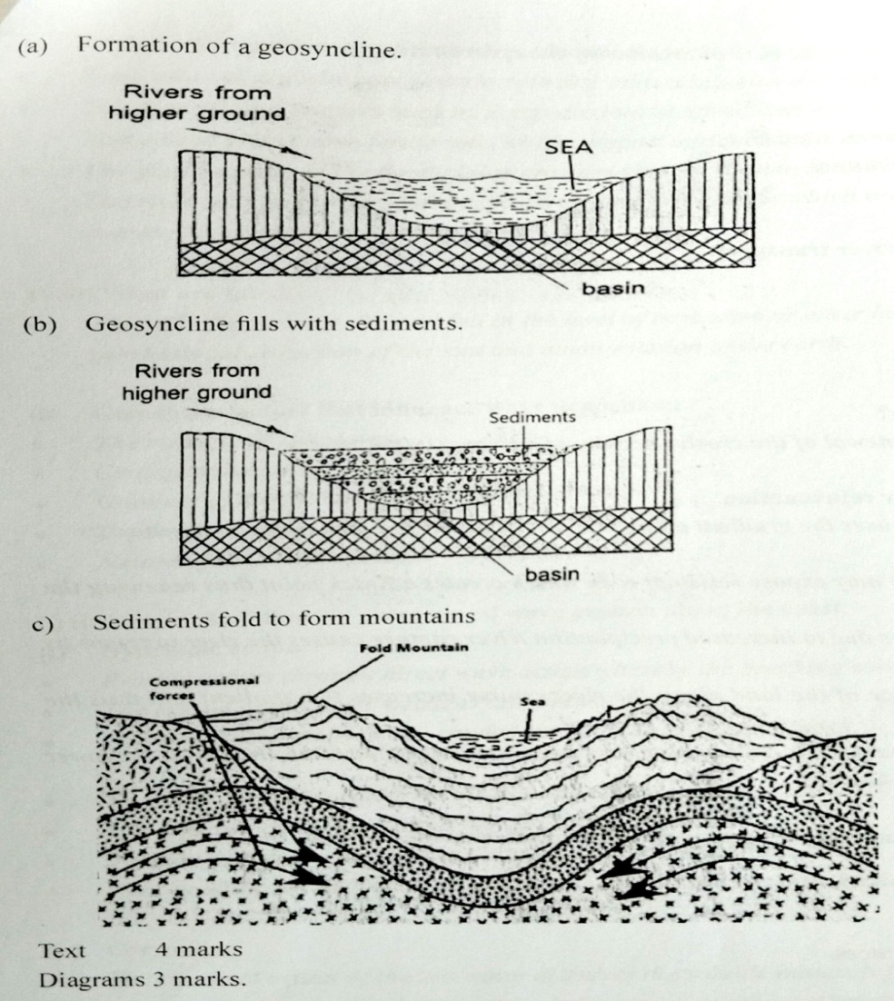
d. Explain the effects of folding on physical environment. (8 marks)
- Folding leads to the formation of various relief features such as fold mountains and valleys
- Fold mountains cause heavy rainfall on the windward slopes as warm moist air rises up.
- Fold Mountains receive heavy rainfall in the windward slopes leading to the growth of thick forests.
- Some fold mountains lead to warmer and cooler temperatures between the north and south facing slopes in either of the hemispheres.
- The Fold Mountains are characterized by cold descending winds, which cause frost/temperature inversion in the lowlands and valleys.
- Fold Mountains receive heavy rainfall, which give rise to major rivers.
- Folding process created crustal weakness, which triggered off volcanic activities/earthquakes.
- The leeward slopes of some Fold Mountains create rain shadow effect, which results in little rainfall.
9. a. (i) What are tides? (2 marks)
They are the periodic rise and fall in the level of ocean/sea or other large water bodies as a result of gravitational attraction of the sun and moon/rotation of earth.
(ii) Give three factors that influence wave deposition. (3 marks)
- The strength of the waves.
- Configuration of the coastline.
- Gradient of the shore.
- Depth of the water.
- Nature of the materials/load.
b. (i) Explain the following processes of wave erosion along the coast. (2 marks)
(ii) Hydraulic action (2 marks)
Erosion occurs through direct wave action whereby the breaking waves hit against rock surface/cliff.
The impact of the water weakens and breaks the rocks.
The loose rock materials are carried into the sea by the backwash.
(iii) Corrosion (2 marks)
The chemical action of the sea water dissolves the soluble minerals found on the cliff face or seabed.
The solution is moved in backwash and the process is repeated resulting into erosion.
c. Describe the formation of the following coastal features.
i) Stack (5 marks)
- Ocean/sea waves attack both sides of a headland at right angle
- The waves erode through abrasion and hydraulic actions forming caves on both sides of the headland.
- Eventually the caves merge leading to formation of an arch.
- The roof of the arch collapses due to continued erosion leading to isolation of part of the headland on the seaward side.
- The isolated headland is the stack.
ii) Spit (4 marks
- A spit develops from sediments supplied by long shore drift
- As the long shore drift comes across a headland which disrupts the smooth flow and the movement is haltered leading to deposition of the sediments.
- The deposition continues extending into a bay with one end attached to the land.
- More materials are piled up eventually forming an elongated low-lying ridge towards the sea.
- The elongated low-lying ridge is known as a spit.
d. You are planning to carry out a field study along the coast of Kenya.
(i) State four preparations that you will make for the study. (4 marks)
- Setting up objectives and hypotheses
- Getting permission from the necessary authorities
- Conducting a reconnaissance / pre-visit
- Assembling various tools/equipment to use
- Preparing a working schedule
- Identifying methods of data collection.
(ii) Name three emerged highland features you are likely to identify. (3 marks)
- Raised beaches
- Raised wave cut platforms
- Raised cliffs
- Raised caves
- Raised arches
10. a. (i) Name two major deserts found in Africa. (2 marks)
- Sahara
- Kalahari
- Namib
The diagram below represents features resulting from wind erosion in a desert. Use it to answer question a (ii)
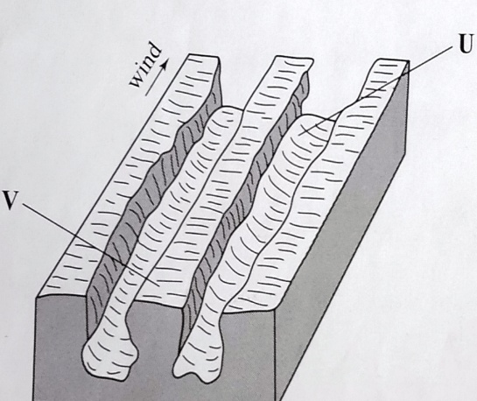

(ii) Name the features marked U and V. (2 marks)
U - furrow
V – yardang
b. Describe the three processes through which wind transports its load. (6 marks)
i) Suspension p1
- Very fine particles such as dust are picked up by the wind
- They are carried to great heights and over long distance
ii) Saltation p1
- Medium sized particles are moved along the ground surface by bouncing or hopping.
iii) Surface creep/ rolling p1
- Heavy materials are pushed and rolled along the ground by strong winds over short distance.
P – 3
D - 3 6 mks
c. Using a well labelled diagram, describe how a barchans is formed. (7 marks)
- Wind blows constantly towards one direction for quite some time.
- Sand deposition occurs around an obstruction like a rock or crop
- Accumulation of more sand leads to formation of a bigger mound of sand.
- Wind carries sand forward along the edges of the mound leading to development of horns.
- Horns grow longer and the mound gradually assumes a crescent shape
- The crescent shaped feature is known as a barchans.
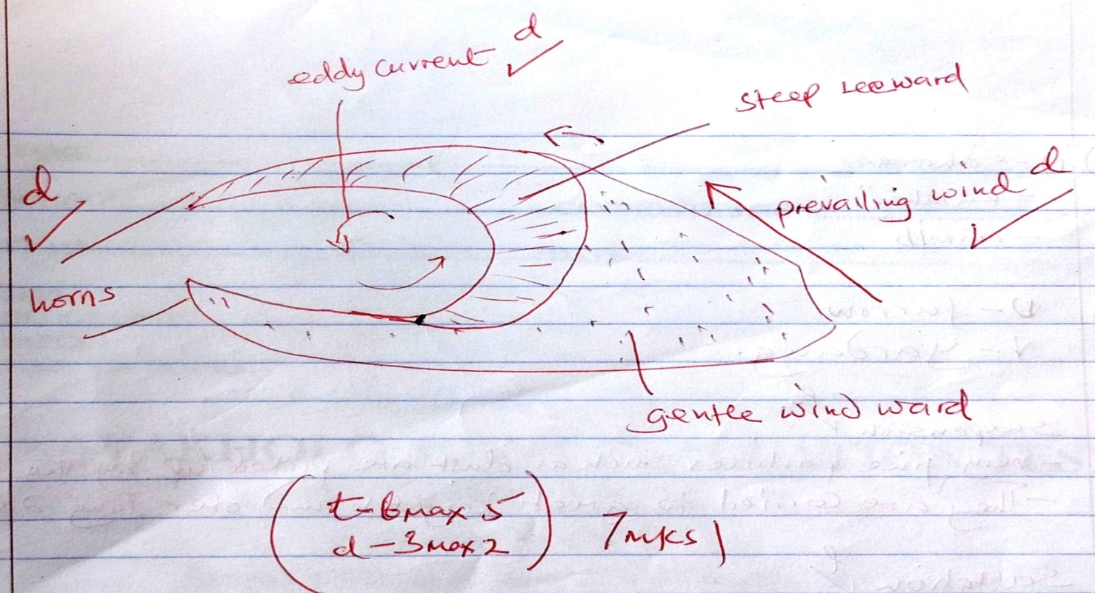
d. Explain four ways in which desert features are of significance to human activities. (8 marks)
- Features such as Zeugens, Yardangs and rock pedestals attract both domestic and foreign tourist promoting tourism.
- Deflation hollows formed in desert may contain water that can be used for livestock, irrigation or domestic purpose.
- Loose deposits in water areas are used for farming promoting agriculture e.g in n. China.
- Dwellings carved out of loose deposits especially in china and Europe in winter and cool in summer.
- Extensive bare lands in deserts form good sites for testing military weapons, car and jet engines.
- Sand dunes can cover roads making travelling difficult.
- Badlands, Wadis and Mesas may make construction of transport links difficult.
4 x 2 = 8 mks

THIS IS THE LAST PRINTED PAGE.

