
THE G8 EXAMINATION
Kenya Certificate of Secondary Education
FORM 4 TERM 2- JUNE 2026

121/1
MATHEMATICS
PAPER 1
TIME: 2 ½ HOURS

Name: ________________________________________Adm No. _________
Class: _________ Candidate’s Signature: __________ Date: _______________

INSTRUCTIONS TO CANDIDATES
- Write your name, admission number and class in the spaces provided above.
- Sign and write the date of examination in the spaces provided above.
- This paper consists of two sections; Section I and Section II.
- Answer all the questions in Section I and any five questions from Section II
- Marks may be given for correct working even if the answer is wrong.
- Non-programmable silent electronic calculators and KNEC Mathematical tables may be used, except where stated otherwise.

FOR EXAMINER’S USE ONLY
SECTION I

1 | 2 | 3 | 4 | 5 | 6 | 7 | 8 | 9 | 10 | 11 | 12 | 13 | 14 | 15 | 16 | Total
Section II
17 | 18 | 19 | 20 | 21 | 22 | 23 | 24 | Total

Grand Total

SECTION I (50 Marks)
Answer ALL questions in this section in the spaces provided
- Without using mathematical tables or calculator evaluate; (3mks)

.√1.90× 0.032 × 1.08
2.00 × 0.0038

- Simplify completely
9a ² y −16b² y ³

4by ² − 3ay
(3mks)

- A water tank has a capacity of 50 litres. A similar model tank has a capacity of 0.25litres. if the larger tank has a height of 100cm. calculate the height of the model tank. (3mks)

- Simplify √12𝑥4 𝑦−1 𝑍5
3𝑥−2𝑦−3 𝑍3

(2 mks)

- One interior angle of a certain polygon is 840. If each of the other angles is 1470, how many sides does this polygon have? (3 mks)

- During a certain period the exchange rates at a Pesa point were;
Buying shs Selling shs
Riyal 19.68 19.78

A tourist arrived with 5480 Riyal which he changed to Kshs. He spend ² of the total in visiting various
3
sites. As he was leaving he changed all he had to Riyal. How much did he leave with? Answer to 1
d.p. (3 mks)

- Find the area of the triangle below given that lines AB=25cm, BC = 15cm, AC = 14cm, BD =
B

28cm and
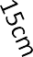
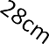
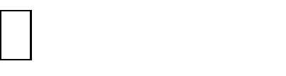
CBD = 32(4mks)

32

D
C
A

- A shear parallel to the x-axis maps point (1,2) onto a point (7, 2). Determine the shear factors and hence state the shear matrix (invariant line is y = 0) (3mks)

- The following data was obtained from the mass of a certain animal. Complete the table and the histogram below. (3 marks)
Mass(kg) | Frequency
41-50 | 20
51-55
56-65 | 40

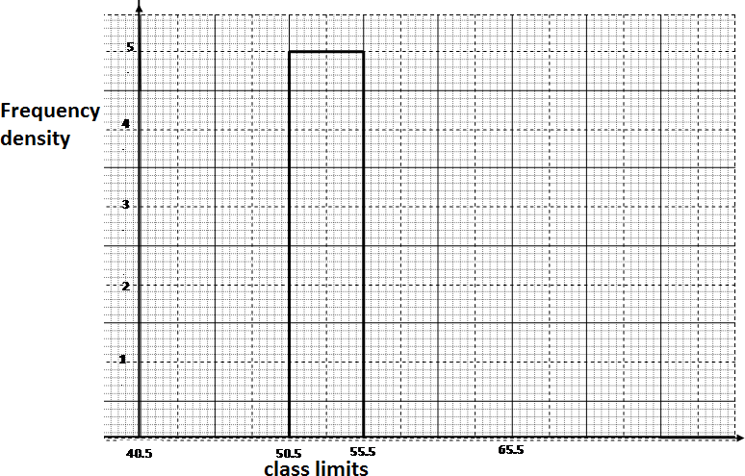

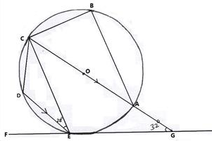
- The diagram below shows a circle ABCDE. The line FEG is a tangent to the circle at point E. Line DE is parallel to CG,

Calculate
  - AEG (2mks)

  - ABC (2mks)

- Wasike and Wanjala live 40km apart. Wasike starts cycling from his home at 8.00a.m toward’s Wanjala’s house at 16km/h. Wanjala stars cycling towards Wasike’s house 30 minutes later at 8km/h. what time did they meet. (3mks)

- The line which joins the point A (3, K) and B (-2, 5) is parallel to the line whose equation is 5y+2x-7=0. Find the value of K. (3mks)

- Given that Cos A = ⁵
13
and angle A is acute, without using tables or calculator, find the value

of (3 mks)
2 tan A + 3 sin A.

- Find the greatest integral value of x which satisfies. ^{2x} ⁺ ³
2
< 8 −3x
5
< 5x + 6
3
(3mks)

- The figure below (not drawn to scale) is a right pyramid with slant height of 5cm and square base of 3cm.
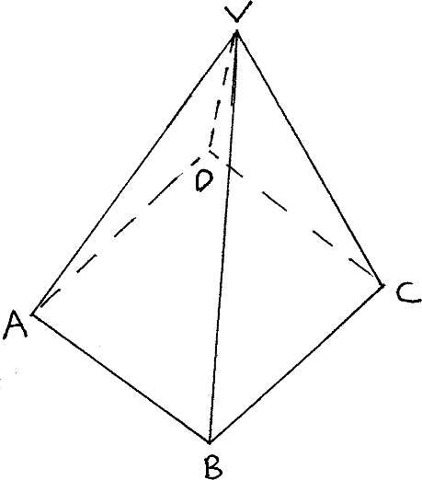

  - Draw its net and label it. (2mks)

  - Calculate the total surface area. (2mks)

- A plane leaves town P to town Q on a bearing of 130º and a distance of 350km. it then flies 500km on a bearing of 060º to town R. Find, by scale drawing the distance between town R and town P. (3 mks)

SECTION II: (50 MARKS)
Answer only FIVE question from this section.
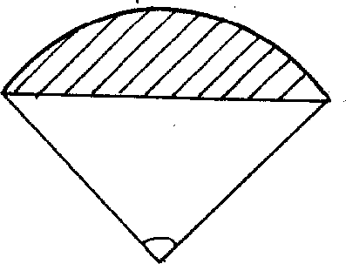
- The ends of the roof of a workshop are segment of a circle of radius 10m. The roof is 20m long .The angle at the centre is 1200 as shown in the figure below.
10m
10m
120⁰

  - Calculate:
- The area of one end of the roof. (4mks)

- The area of the curve surface of the roof. (2mks)

  - What would be cost to the nearest shilling of covering the two ends and the curved surface with galvanized iron sheet costing sh.80 per square meter. (4mks)

- A rectangular tank whose internal dimensions are 1.7m by 1.4m by 2.2m is three quarters full of milk.
- Calculate the volume of milk in litres. (3 marks)

- The milk is packed in small packets in a shape of a right pyramid with an equilateral base triangle of side 16cn. The height of each packet is 13.6cm. Full packets obtained are sold at ksh.25 per packet.
  - The volume in cm3 of each packet to the nearest whole number. (3 marks)

  - The number of full packets of milk. (2 marks)

  - The amount of money realized from the sell of milk. (2 marks)

- (a) On the grid provided below, plot the polygon A(3, 7), B(5, 5), C(3, 1), D(1, 5) on a cartesian plane (2mks)
- A1B1C1D1 is the image of ABCD under a translational T(−6 . Plot A1B1C1D1 and
)
−9
state its coordinates. (2mks)
- Plot A11B11C11D11, the image of A1B1C1D1 after a rotation about (-1, 0) through a
positive quarter turn. State its coordinates. (3mks)
- A111B111C111D111 is the image of A11B11C11D11 after a reflection in the line Y=x + 2.
Plot A111B111C111D111and state its coordinates (3mks)

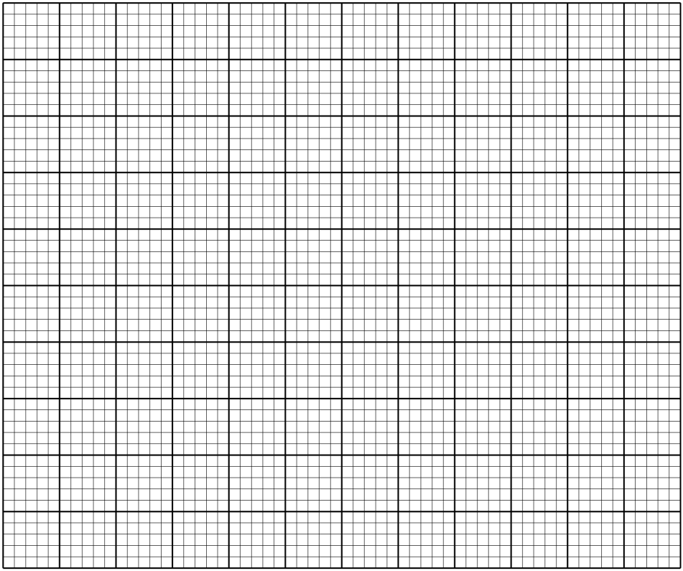

- A straight line passes through the points (8, -2) and (4,-4).
- Write its equation in the form ax + by +c = 0, where a, b and c are integers. ( 3 Marks)

- If the line in (a) above cuts the x-axis at point P, determine the coordinates of P. (2 Marks)

- Another line, which is perpendicular to the line in (a) above passes through point P and cuts the y axis at the point Q. Determine the coordinates of point Q. (3 Marks)

- Find the length of QP (2 Marks)

- Matrix P is given by
⎛ 4 7 ⎞
⎜⎜ ⎟⎟
5
8
⎝ ⎠
  - Find p-1 (3mks)

  - Two institutes regions and Alphax purchased beans at sh.B per bag and maize at sh.M per bags. Regions purchased 8 bags of beans and 14 bags of maize for sh. 47,600. Alphax purchased 10 bags of beans and 16 bags of maize for sh. 57,400.
    - Form a matrix equation to represent the information above (2mks)

  - Use the matrix p-1 to find the prices of one bag of each item (3mks)

(d)The price of bean later went up by 5% and that of maize remain constant. Regions bought the same quality of beans but spent the same total amount of money as before on the two items. State the new ratio of beans and maize. (2mks)

- In the diagram below, the coordinates of points A and B are (1, 6) and (15, 6) respectively. Point N is on OB and that 3 ON = 2 OB.ne OA is produced to L such that OL = 3 OA
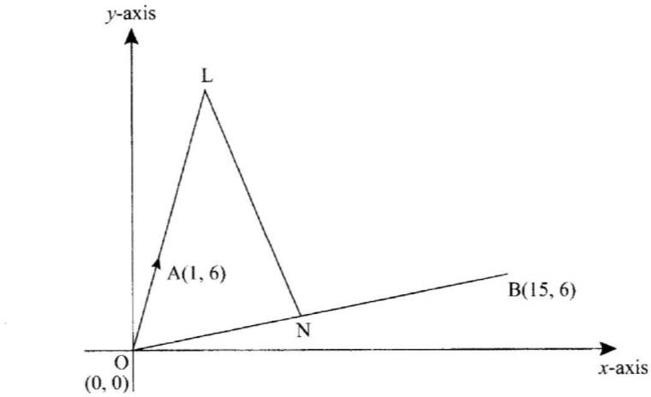
  - Vector LN. (3 marks)

  - Given that a point M is on LN such that LM:MN = 3:4, find the coordinate of M. (2 marks)

  - If line OM is produced to T such that OM:MT = 6:1
    - Find the position vector of T. (1 mark)

    - Show that points L, T and B are collinear. (4 marks)

- Complete the table below for the functions
y = 2x² − 3x −5 for − 2 ≤ x ≤ 3
(2 mks

-1 0 1 2 3
-2
x
y
- Draw the graph of y = 2x² − 3x −5 from the table above. (2 mks)

- Use your graph to solve the equation y = 2x² − 3x −5 =0 (1 mk)

(d) From your graph, find the value of X which satisfy the simultaneous equations. (1 mk) y = 2x² − 3x −5
y = 2x − 2

(e )Write down the equation which is satisfied by the values of x in (e) above in the form
ax2 + bx + c = 0 (2 mks)

- The diagram below shows a circle ABC with AB=12cm, BC=15cm, and AC=14cm
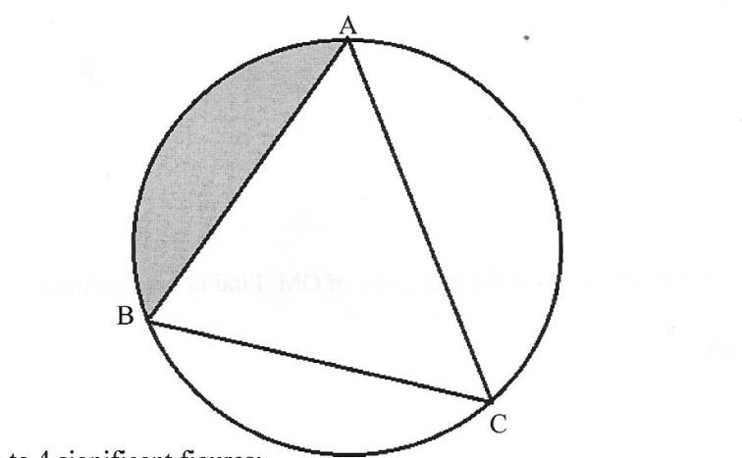

Calculate to 4 significance figures:
  - The angle ACB (3mks)

  - The radius of the circle. (3mks)

  - The area of the shaded region (4mks)

