
THE G8 EXAMINATION
Kenya Certificate of Secondary Education
FORM 4 TERM 2- JUNE 2026

121/2
MATHEMATICS ALT. A
Paper 2
Time: 2 ½ Hours

Name: _____________________________________________ Adm No. _________
Class: _________ Candidate’s Signature: ____________ Date: _______________

INSTRUCTION TO CANDIDATES
a) Write your name and Index number in the spaces provided above.
b) Sign and write the date of examination in the spaces provided above.
c) The paper consists of two sections. Section I and Section II.
d) Answer ALL the questions in Section I and any FIVE questions in Section II.
e) Show all the steps in your calculations, giving your answer at each stage in the spaces provided
below each question.
f) Marks may be given for correct working even if the answer is wrong.
g) Non-programmable silent electronic calculators and KNEC Mathematical tables may be used
except where stated otherwise.
h) Candidates should answer the questions in English.
i) This paper consists of 15 printed pages.
j) Candidates must check the question paper to ascertain that all pages are printed as indicated
and that no question(s) is/are missing.

FOR EXAMINER’S USE
SECTION I
1 | 2 | 3 | 4 | 5 | 6 | 7 | 8 | 9 | 10 | 11 | 12 | 13 | 14 | 15 | 16 | Total

SECTION II

17 | 18 | 19 | 20 | 21 | 22 | 23 | 24 | Total

Grand Total

SECTION 1 (50 MARKS) Answer all questions in this section
- Solve the equation $\frac{1}{3} (2x+1)+\frac{1}{4}\left(5x-1\right)= \frac{1}{2}$ (3mks)

- a). Expand (1 – 2x)⁴ (1mk)

b). Use your expansion to find the value of (0.96)⁴ correct to 4 s.f (2mks)

- The expression $1+\frac{x}{2}$ is taken as an approximation for 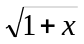. Find the percentage error in doing
so if x = 0.44 (3mks)

- Solve for x in the equation log₈ (x+6) - log₈(x-3) = $\frac{2}{3}$ (4mks)

- Make p the subject if the formula (3mks)

$E + x =x + \frac{p^{2}-3u}{y-3xp^{2}}$

- Mr Chitechi deposited sh. 24,000 in a fixed account for a period of 24 months .The bank pays compound interest on quarterly basis. At the end of this period, Mr. Chitechi’s account had ksh.64,200. Determine the rate at which interest is paid per annum. (3mks)

- In the figure below PT is a tangent to the circle at P and AT passes through the centre of the circle.

B
A T

P

If PT =9cm and AT=12cm, find the- radius of the circle correct to 1 d.p. (3mks)

- Find the radius and the centre of the circle whose equation is (3mks)

3x² + 3y² – 6x + 3 + 12y = 0

- Without using a calculator or mathematical tables express $\frac{\sqrt{3}}{1-\cos{{30}^{0}}}$ in surd form and simplify (3mks)

- The table below represents the mass and volume of a liquid measured at room, temperature.

Mass (g) | 8 | 10 | 20 | 21 | 30 | 37 | 52 | 55 | 70
Volume (cm³) | 10 | 13 | 20 | 29 | 35 | 43 | 60 | 63 | 70

a). By plotting the points and drawing the line of best fit, estimate the density to the liquid. (2mks)

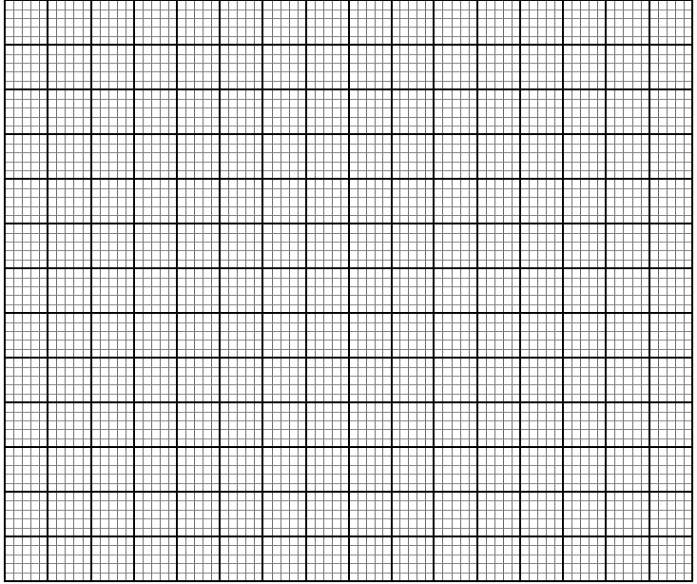

b). Determine the equation of your graph. (2mks)

- The population of two towns Kathwana and Siakago for three years was as follow.

 | 1st year | 2nd year | 3rd year
Kathwana | 40,000 | 48,000 | 56,000
Siakago | 40,000 | 48,000 | 57,600

Calculate the difference in population of the two after six years. (3mks)

- Solve for $∝$ in the equation 6 sin²$∝$ - cos $∝$ – 5 = 0 For Ɵ$≤ ∝ ≤{300}^{o}$ (3mks)

- Arabic coffee costing sh90 per kilogram is mixed with rubusta coffee costing sh.75 per kilogram in the ration 2:3. Calculate the selling price of the mixture per kilogram if a profit of 15% if to be realized to the nearest shilling. (3mks)

- The gradient of a curve at any point is given by 2x-1. Given that the curve passes through point (1,5). Find the equation of the curve. (3mks)

- a). Given that AB=6cm. Construct locus of P such that <APB = 90º. (2mks)

b). Hence determine the area enclosed by the locus of P. (2mks)

- Given the vectors a = 3j + 2k and b = 4i – 7k
Find p if p = 3a – b (2mks)

SECTION II 50 MARKS (Answer any five questions only in this section)

17. In a science class ²/₃ of the class are boys and the rest are girls. 80% of the boys and 90% of the girls are right handed. The probability that the right-handed student will break a test tube in any session is ¹/₁₀ and that for the left-handed student is ³/₁₀ regardless of whether boy or girl.

a) Draw a tree diagram to represent this information (2 marks)

b) Using the tree diagram drawn, find the probability that:
i) A student chosen at random from the class is left handed (2 marks)

ii) A test tube is broken by a left handed student (2 marks)

iii) A test tube is broken by a right handed student (2 marks)

iv) A test tube is not broken in any session (2 marks)

18. The following table shows the rate at which income tax was charged during a certain year.
Monthly taxable income in Ksh. | Tax rate %
0 - 9860 | 10
9861 - 19720 | 15
19721 - 29580 | 20
29581 - 39440 | 25
39441 - 49300 | 30
49301 - 59160 | 35
over 59160 | 40
A civil servant earns a basic salary of Ksh.35750 and a monthly house allowance of sh.12500 and non taxable allowance of ksh 10000. The civil servant is entitled to a personal relief of sh.1062 per month. Calculate:
a) Taxable income (2 marks)

b) Calculate his net monthly tax (5 marks)

c) Apart from the salary the following deduction are also made from his monthly income.
WCPS at 2% of the basic salary, Loan repayment Ksh.1325, NHIF sh.480
Calculate his net monthly earning. (3 marks)

19.A plane S flies from a point P (40ºN, 45ºW) to a point Q ( 35º N, 45ºW) and then to another point T (35ºN, 135ºE).
a) Given that the radius of the earth is 6370km find the distance from P to Q in km. Take  = ²²/₇

(2 marks)

b) Find in nm
i) The shortest distance between Q and T (2 marks)

ii) The longest distance between Q and T ( to the nearest tens) (2 marks)

c) Find the difference in time taken when S flies along the shortest and longest routes if its speed is
420 knots (4 marks)

20. The marks obtained by 50 students in an examination were recorded in the table below

Marks | 0-9 | 10-19 | 20-29 | 30-39 | 40-49 | 50-59 | 60-69 | 70-79
Number of student | 3 | 6 | 10 | 12 | 9 | 5 | 3 | 2
Using 44.5 as the assumed mean, calculate
i) The actual mean mark (4 marks)

ii) The standard deviation to 2 decimal place (3 marks)

iii) The quartile deviation (3 marks)

21. Given that y = 2 sin 2x and y = 3 cos (x+45º)
a) Complete the table below (2 marks)

X | 0 º | 20 º | 40 º | 60 º | 80 º | 100 º | 120 º | 140 º | 160 º | 180 º
2sin 2x | 0 |  | 1.97 |  | 0.68 | -0.68 | -1.73 |  | -1.28 | 0
3 cos (x+ 45 º) | 2.12 | 1.27 |  | -0.78 |  | -2.46 |  |  | -2.72 | -2.12

b) Use the data to draw the graph of y = 2 sin 2x and y = 3 cos (x+45 º) for 0 º ≤ x ≤ 180 º on the same axis on the grid provided below (5 marks)


c) State the amplitude and period of each curve (2 marks)

d) Use the graph to solve the equation 2 sin 2x – 3 cos (x+45 º) = 0 for 0 º ≤ x ≤ 180 º (1 mark)

22.The diagram below shows a right pyramid VPQRS with V as the vertex and rectangular base PQRS. PQ=3cm, QR=4cm and the height of the pyramids is 6cm. M and N are the mid-points of PQ and QR respectively.
V

S R

P Q
a). Calculate
i). the length PV (3mks)

ii). the angle between face VPQ and the base PQRS (2mks)

b). i) the slant height VM and VN. (2mks)

ii) the surface area of the pyramid. (3mks)

23. A small scale farmer wishes to buy some sheep and goat for rearing. Sheep cost sh 400 and goat cost sh.300. The farmer has enough space for only 20 animals and may spend at most sh 6,800.
The number of goats should not exceed twice the number of sheep.
- By letting x and y to represent the number of sheep and goats he can buy respectively, write
down all inequalities from the above information (4 marks)

b) Represent the inequalities on the grid provided (4 marks)

c) From your graph, find the maximum number of animals he can buy at the lowest cost (2 marks)

24.The initial velocity of a particle was 1m/s and it acceleration is given by (2-t) m/s² every second after the start.
a). i). Determine the equation representing its velocity. (2mks)

ii). Find the velocity of the particle during the third second. (2mks)

b). i). Find the equation representing its distance t seconds after the start. (2mks)

ii). What was the distance covered by the particle during the first three seconds. (2mks)

c). Determine the time when the particle was momentarily at rest. (2mks)

