
THE G8 EXAMINATION
Kenya Certificate of Secondary Education
FORM 4 TERM 2- JUNE 2026

233/1 CHEMISTRY Paper 1
(Theory)

JUNE 2026 – Time: 2 hours

Admission No. …………………………………Class.………........…………………………………...

School……………….……………………………….……Date………..….…Signature…………

Instructions to candidates
- Write your Admission Number, Index Number and school in the spaces provided above.
- Sign and write the date of examination in the spaces provided above.
- Answer all the questions in this question paper
- Answer all questions in the spaces provided
- This paper consists of 11 printed pages.
- All workings must be shown clearly where necessary
- Mathematical tables and silent non-programmable calculators may be used

FOR EXAMINERS USE ONLY
QUESTIONS | MAXIMUM SCORE | CANDIDATES SCORE
1-27 | 80 MARKS

- Complete the table below by writing the observations made when aqueous ammonia and aqueous sodium sulphate are added to solutions containing calcium, aluminum and Iron (II) ions. (3 marks)

Ions Present | Aqueous Ammonia | Aqueous sodium sulphate
Ca²⁺
Al³⁺
Fe²⁺

- A group of compounds called chlorofluorocarbons have a wide range of uses but they also have harmful effects on the environment.
- Give one use of chlorofluorocarbons. (1 mark)
………………………………………………………………………………………………………………………………………………………………………………………………….
- State one harmful effect of chlorofluorocarbons on the environment. (1 mark)
………………………………………………………………………………………………………………………………………………………………………………………………….

- (a) Define the term solubility. (1 mark)
…………………………………………………………………………………………………………………………………………………………………………………………………..
(b) 40g of a saturated solution yields 15g of salt when evaporated to dryness.
Calculate the solubility of the salt. (2 marks)
…………………………………………………………………………………………………………………………………………………………………………………………………………………………………………………………………………………………………………………………………………………………………………………………………………
- Element U has atomic number 12 while element V has atomic number 16. How do the melting points of their oxides compare? Explain. (3 marks)
…………………………………………………………………………………………………………………………………………………………………………………………………..
………………………………………………………………………………………………
………………………………………………………………………………………………..

- Hydrogen gas can be prepared by passing steam over heated Magnesium ribbon as shown in the figure below.
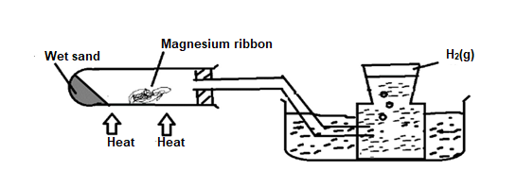
- Explain why the delivery tube must be removed from beneath the water before heating is stopped. (1 mark)
……………………………………………………………………………………………………………………………………………………………………………………………………
- Explain why sodium metal is not suitable for this experiment. (1 mark)
……………………………………………………………………………………………………………………………………………………………………………………………………
- Give two reasons why hydrogen is not commonly used as fuel. (1 mark)
……………………………………………………………………………………………………………………………………………………………………………………………………
- (a) State Graham’s law of diffusion. (1 mark)
……………………………………………………………………………………………………………………………………………………………………………………………………
(b) Explain why a balloon filled with helium gas deflates faster than a balloon of the same size filled with argon gas. (He = 4.0, Ar = 40) (2 marks)
……………………………………………………………………………………………………………………………………………………………………………………………………………………………………………………………………………………………………
- When bromine gas reacts with aqueous sodium hydroxide, the equilibrium represented by the equation: is established

Br_{2(aq)} + 2OH⁻_{(aq)} Br_{(aq)} + OBr⁻_{(aq)} + H₂O
Orange Colourless
What observations would be made if a few drops of Sulphuric (VI) acid were added to the equilibrium mixture? Explain (2marks)
………………………………………………………………………………………………
…………………………………………………………………………………………….
…………………………………………………………………………………………….
…………………………………………………………………………………………….

- Ethene reacts with bromine as shown in the following chemical equation.
C₂H₄ + Br₂ → C₂H₄Br₂
Using bond energies in the table below, calculate the enthalpy change (H) for the reaction. (3 marks)
Bond | Bond energy levels Kj/mol
C= C | 599
C - H | 412
Br- Br | 193
C - C | 349
C – Br | 276
……………………………………………………………………………………………………………………………………………………………………………………………………………………………………………………………………………………………………………………………………………………………………………………………………………………………………………………………………………………………………………………………………………………………………………………………..
- Hydrogen chloride gas can be prepared by reacting rock salt with an acid.
- Write an equation for the reaction between rock salt and the acid. (1 mark)
……………………………………………………………………………………………………………………………………………………………………………………………
- Give two chemical properties of hydrogen chloride gas. (1mark)
……………………………………………………………………………………………………………………………………………………………………………………………..
- Calcium oxide can be used to dry ammonia gas. Explain why Calcium oxide is not used to dry hydrogen chloride gas. (1 mark)
………………………………………………………………………………………………………………………………………………………………………………………………

- The table below shows some properties of three substances. Complete the table by filling in the types of forces and structures in each substance. (3 marks)
Substance | M.P.°C | B.P.°C | Electrical conductivity |  | Type of forces | Structure
 |  |  | Solid | Molten
X | -101 | -35 | Poor | Poor
Y | 650 | -1110 | Good | Good
Z | 714 | -1142 | Poor | Good

- Study the table below and answer the questions that follow. The letters do not represent to actual symbols of the elements.
Element | No. of electrons | Mass Number
L | 7 | 14
M | 12 | 24
N | 15 | 31
K | 20 | 40
- Write the chemical formula of the compound formed between L and M. (1mark)
………………………………………………………………………………………………
- Given that the chemical formula of a molecule of element N is N4, write a balanced equation for the reaction between N and limited oxygen. (1 mark)
………………………………………………………………………………………………………………………………………………………………………………………………
- State the family name and the period to which K belongs in the periodic table.
Family………………………………………………………………………… (1mark)

Period ………………………………………………………………………… (1mark)

- When excess lead (II) nitrate solution was added to a solution containing sodium chloride, the precipitate formed was found to weigh 5.5g. Determine the amount of sodium chloride in the solution. (Pb = 207, Cl = 35.5, Na = 23). (3 marks)
………………………………………………………………………………………………………………………………………………………………………………………………………………………………………………………………………………………………………………………………………………………………………………………………
- The following table shows the effects of heat on three metal nitrates X, Y and Z.
Metal nitrate | Products on heating
X | Metal oxide + oxygen + Nitrogen(IV) oxide
Y | Metal nitrite + oxygen
Z | Metal + oxygen + Nitrogen(IV) oxide
- Arrange the metals X, Y and Z in order of decreasing reactivity. (1 mark)
……………………………………………………………………………………………………………………………………………………………………………………………..
- Name a metal that is likely to be Z. (1 mark)

……………………………………………………………………………………
- What is the effect of heat on Carbonate of metal Y? Give a reason. (1 mark)
……………………………………………………………………………………………………………………………………………………………………………………
- Starting with lead metal, describe how a solid sample of lead (II) carbonate can be prepared. (3 marks)
……………………………………………………………………………………………………………………………………………………………………………………………………………………………………………………………………………………………………………………………………………………………………………………………………………………………………………………………………………………………………
- (a) A sample of water in a beaker was found to boil at 101.5°C at 1 atmospheric pressure. Assuming that the thermometer was not faulty, explain this observation. (1 mark)
……………………………………………………………………………………………………………………………………………………………………………………………
b) Describe an experimental procedure that can be used to extract oil from nut seeds. (2marks)
…………………………………………………………………………………………………………………………………………………………………………………………………………………………………….……………………………………………………………………………………………………………………………………………………………………………………………………………………………….
- a) State Gay-Lussac' Law. (1 mark)
……………………………………………………………………………………………………………………………………………………………………………………
b) 180cm³ of Nitrogen (II) oxide gas was reacted with 400cm³ of Oxygen gas. Calculate the total volume of the gases at the end of the reaction. (2 marks)
………………………………………………………………………………………………………………………………………………………………………………………………………………………………………………………………………………

- The flow chart below shows the process that occurs in the manufacture of nitric (V) acid.
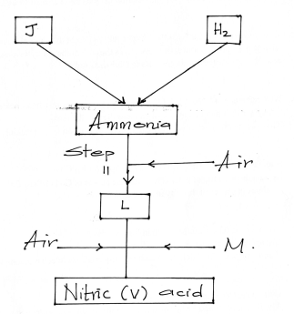
a) Name the substances. L, M [1 mark]
L……………………………………………………………………………………….

M………………………………………………………………………………………
b) In the industrial manufacture of ammonia, ground iron is used as a catalyst. State two other conditions for the process. [1 mark]
……………………………………………………………………………………
…………………………………………………………………………………….
…………………………………………………………………………………………

c) Identify a catalyst that can be used in Step II. [1 mark]
……………………………………………………………………………………..
…………………………………………………………………………………….
- . When a sample of concentrated sulphuric (VI) acid was left in an open beaker in a room for two days, the volume was found to have increased slightly.
- What property of concentrated sulphuric (VI) acid is shown by the above reaction? (1 mark)
………………………………………………………………………………………………
- State one use of concentrated sulphuric (VI) acid that depends on the property named above. (1 mark)
………………………………………………………………………………………………
- Name the apparatus that can be used to:
- Measure fixed volume of solutions. (1 mark)
…………………………………………………………………………………………………
- Lower a burning piece of magnesium ribbon into a gas jar. (1 mark)
…………………………………………………………………………………………………
- Store and keep substances free from moisture. (1mark)
………………………………………………………………………………………………………………………………………………………………………………………………
- a) Explain why a high temperature is required for nitrogen to react with oxygen. (1 mark)
………………………………………………………………………………………………………………………………………………………………………………………………
b) Dry ammonia and dry oxygen were reacted as shown in the diagram below.
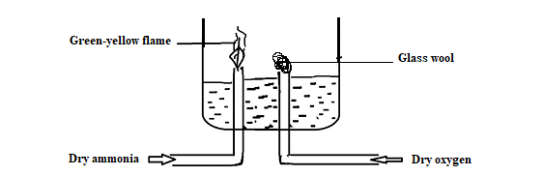
- What is the purpose of the glass wool? (1 mark)
…………………………………………………………………………………………
- Write an equation for the reaction that leads to the production of the green-yellow flame. (2 marks)
…………………………………………………………………………………………
………………………………………………………………………………………..
- The diagram below shows an incomplete set up used to prepare sulphur(IV) oxide in the laboratory.
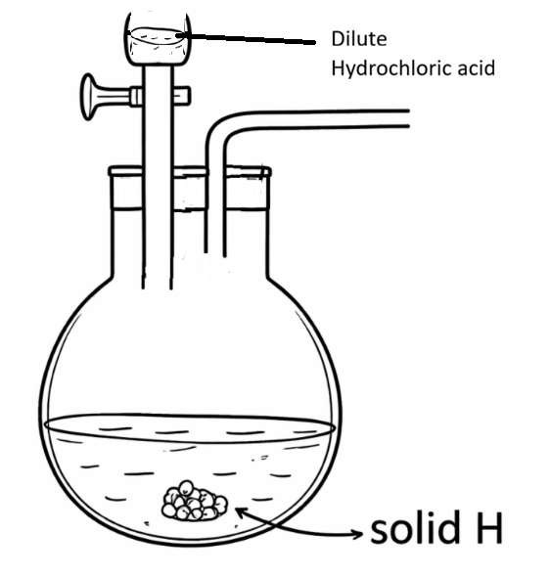

- Complete the set up diagram above to show how dry Sulphur(IV)oxide gas would be collected. (2 marks)
- Identify solid H. (1 mark)

……………………………………………………………………………………………………………………………………………………………………………………………..

- Temporary water hardness can be removed by boiling
- What is hard water. (1 mark)
…………………………………………………………………………………………………………………………………………………………………………………………….
- Write an equation to show how temporary hardness in water can be removed by boiling. (1 mark)
……………………………………………………………………………………………………………………………………………………………………………………. c) State one advantage of hard water. (1 mark)
…………………………………………………………………………………………
- a) Without using hydroxide solution, explain how you can distinguish carbon (II)oxide and carbon (IV)oxide gases. (2 marks)
…………………………………………………………………………………………
…………………………………………………………………………………………
b) State one use of carbon(IV)oxide which is also a use of ammonia. (1 mark)
…………………………………………………………………………………………………………………………………………………………………………………………….
- The graph below shows the behavior of a fixed mass of a gas at constant temperature
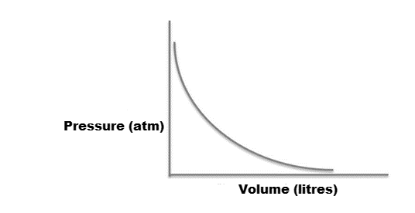
- What is the relationship between the volume and pressure of the gas. (1 mark)
…………………………………………………………………………………………………………………………………………………………………………………………………….
- 3 litres of oxygen gas at 1 atmosphere pressure were compressed to 2 atmospheres at constant temperature. Calculate the new volume occupied by the oxygen gas. (2 marks)
……………………………………………………………………………………………………………………………………………………………………………………………………………………………………………………………………………………………………..
- The figure below shows a flame obtained from a Bunsen burner.
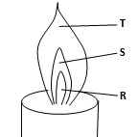

(a) Name the type of flame. (1 mark)
……………………………………………………………………………………….
……………………………………………………………………………………….
(b) A matchstick head placed at region R will not ignite. Explain. (1 mark)
………………………………………………………………………………………….
…………………………………………………………………………………………
…………………………………………………………………………………………

(c) Name region S. (1 mark)
………………………………………………………………………………………….
………………………………………………………………………………………….
- Use the cell representation below to answer the questions that follow.
Ni(s)/ Ni²⁺(aq) // Ag⁺(aq) /Ag(s)
(i ) State what the symbol // represents in the diagram. (1mark)
………………………………………………………………………………………………...
(ii ) Write the equation for the reaction that occurs in the cell. (1mark)
…………………………………………………………………………………………………..
…………………………………………………………………………………………………..
(iii ) Given that the E^{Ɵ} of Ag⁺(aq) /Ag(s) half -cell is +0.80V ,calculate the E^{Ɵ} of the Ni²⁺(aq)/ Ni(s) half-cell given that the e.m.f. of the cell is 1.06V. (2marks)
………………………………………………………………………………………………………………………………………………………………………………………………………………………………………………………………………………………………………………………………………………………………………………………………………
- The molecular formula of a hydrocarbon is C₁₁H₂₄,
The hydrocarbon can be converted into other hydrocarbons as shown below.
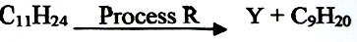
(a) Name process R ………………………………………… (1 mark)
(b) Draw the structural formula of Y and give its name. (1mark)
……………………………………………………………………………………………...
………………………………………………………………………………………………

