
THE G8 EXAMINATION
Kenya Certificate of Secondary Education
FORM 4 TERM 2- JUNE 2026

443/1
AGRICULTURE PAPER 1
TIME: 2 HOURS

Name: _____________________________________________ Adm No. _________
Class: _________ Candidate’s Signature: ____________ Date: _______________
Instructions to the canditates
- Write your name and index number in the space provided above
- Sign and write the date of examination in the space provided above
- This paper consists of three sections A, B and C
- .Answer all the Questions in section A and B and only two Questions in section C

FOR EXAMINERS USE ONLY
SECTION | QUESTIONS | MAXIMUM SCORE | CANDITATES SCORE
A | 1-16
B | 17-20
C | 21-23
 | TOTAL SCORE

SECTION A (30 Marks)
Answer all the questions in this section in the spaces provided.
- Name four biological agents of weathering. (2 marks)
………………………………………………………………………………………………………………………………………………………………………………………………………………………………………………………………………………………………………………………………………………………………………………………………………………………………………………………………………………………………………………………………………………………………………………
- Give four reasons for proper drying of grains before storage. (2 marks)
………………………………………………………………………………………………………………………………………………………………………………………………………………………………………………………………………………………………………………………………………………………………………………………………………………………………………………………………………………………………………………………………………………………………………………
- Name four records that a maize farmer should keep. (2 marks)
………………………………………………………………………………………………………………………………………………………………………………………………………………………………………………………………………………………………………………………………………………………………………………………………………………………………………………………………………………………………………………………………………………………………………………
- Give four causes of land fragmentation in Kenya. (2 marks)
………………………………………………………………………………………………………………………………………………………………………………………………………………………………………………………………………………………………………………………………………………………………………………………………………………………………………………………………………………………………………………………………………………………………………………
- Outline four management practices carried out on trees in agroforestry. (2 marks)
………………………………………………………………………………………………………………………………………………………………………………………………………………………………………………………………………………………………………………………………………………………………………………………………………………………………………………………………………………………………………………………………………………………………………………
- Give four reasons for pasture conservation. (2 marks)
………………………………………………………………………………………………………………………………………………………………………………………………………………………………………………………………………………………………………………………………………………………………………………………………………………………………………………………………
- State two functions of young farmers club. (1 mark)
………………………………………………………………………………………………………………………………………………………………………………………………………………………………………………………………………………………………………………………………………………
- Name three books of accounts that are beneficial to a farmer. (1½ marks)
………………………………………………………………………………………………………………………………………………………………………………………………………………………………………………………………………………………………………………………………………………………………………………………………………………………………………………………………
- Name four systems of farming. (2 marks)
………………………………………………………………………………………………………………………………………………………………………………………………………………………………………………………………………………………………………………………………………………………………………………………………………………………………………………………………………………………………………………………………………………………………………………
- State four reasons for irrigating a crop land. (2 marks)
………………………………………………………………………………………………………………………………………………………………………………………………………………………………………………………………………………………………………………………………………………………………………………………………………………………………………………………………………………………………………………………………………………………………………………
- Give four benefits a farmer is likely to get by having a land title deed. (2 marks)
………………………………………………………………………………………………………………………………………………………………………………………………………………………………………………………………………………………………………………………………………………………………………………………………………………………………………………………………………………………………………………………………………………………………………………

- Give two examples in each case of the following in the production of Kales.
  - Variable Cost (1 mark)
………………………………………………………………………………………………………………………………………………………………………………………………………………………………………………………………………………………………………………………………………………
  - Fixed Cost (1 mark)
………………………………………………………………………………………………………………………………………………………………………………………………………………………………………………………………………………………………………………………………………………
- State three factors considered when classifying crop pests. (1½ Marks)
………………………………………………………………………………………………………………………………………………………………………………………………………………………………………………………………………………………………………………………………………………………………………………………………………………………………………………………………
- State four indicators of economic development of a country. (2 marks)
………………………………………………………………………………………………………………………………………………………………………………………………………………………………………………………………………………………………………………………………………………………………………………………………………………………………………………………………………………………………………………………………………………………………………………
- State two farming practices which can enhance proper light penetration on a crop. (1 mark)
………………………………………………………………………………………………………………………………………………………………………………………………………………………………………………………………………………………………………………………………………………
- Given that a maize crop is planted at a spacing of $80cm×25cm$, calculate the plant population in 2 hectares of land, if two maize seeds are planted per hole. (3 marks)
………………………………………………………………………………………………………………………………………………………………………………………………………………………………………………………………………………………………………………………………………………………………………………………………………………………………………………………………………………………………………………………………………………………………………………

SECTION B (20 Marks)
Answer all the questions in this section in the spaces provided.
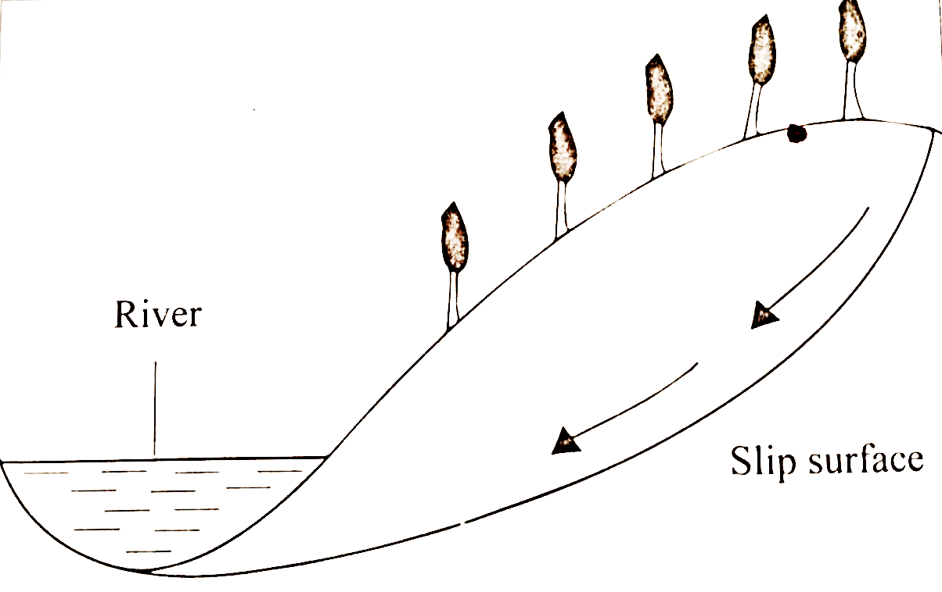
- Study the diagram below and answer questions that follow.
- Identify the type of erosion above. (1 mark)
……………………………………………………………………………………………………………………………………………………………………………………………………………………
- State four factors influencing the above types of erosion. (4 marks)
……………………………………………………………………………………………………………………………………………………………………………………………………………………………………………………………………………………………………………………………………………………………………………………………………………………………………………………………………………………………………………………………………………………
- Diagram A & B shows weeds.
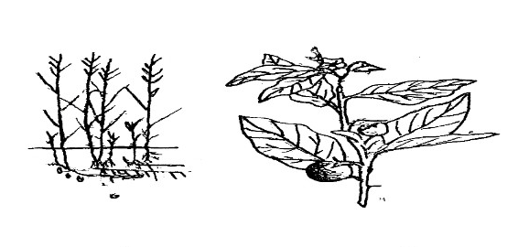
B
A
- Identify the weeds. (2 marks)
    - A:……………………………………………………………………………………………………
    - B:……………………………………………………………………………………………………
- State two economic importance of the weed shown in A. (2 marks)
……………………………………………………………………………………………………………………………………………………………………………………………………………………………………………………………………………………………………………………………….
- Classify the weed labelled A according to growth cycle. (1 mark)
………………………………………………………………………………………………………….
- The diagram below shows a section of a plant which the planting material illustrated was obtained.
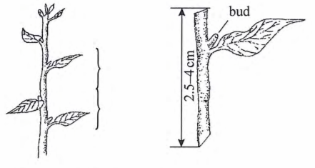
- Identify the planting material illustrated above. (1 mark)
……………………………………………………………………………………………………………………………………………………………………………………………………………………
- Give two reasons why only the middle part of the plant was used to prepare planting materials. (2 marks)
……………………………………………………………………………………………………………………………………………………………………………………………………………………
………………………………………………………………………………………………………….
- Apart from using the middle part of the plant, explain two precautions that should be observed when preparing the illustrated planting materials. (2 marks)
………………………………………………………………………………………………………………………………………………………………………………………………………………………………………………………………………………………………………………………………

- The following illustration shows different production function curves in Agricultural economics. Study them and answer the questions that follows.
Output
Q | P | R
Input | 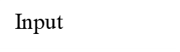  Output | Output

- State the production function curves labelled: (3 marks)
    - Q:…………………………………………………………………………………………………...
    - P: …………………………………………………………………………………………………...
    - R: …………………………………………………………………………………………………...

- Name the law derived from the production function labelled R. (1 mark)
……………………………………………………………………………………………………………………………………………………………………………………………………………………
- Which production curve is rare in Agriculture? (1 mark)
……………………………………………………………………………………………………………………………………………………………………………………………………………………

SECTION C (40 Marks)
Answer any two questions from this section in the spaces provided after question 23.

- Explain why weeds are difficult to control in a maize plantation. (6 Marks)
- The following information was obtained from Ushindi Farm for the year ended 31st December 2025.
Particulars | Ksh
Opening Valuation | 30,000
Paid wages | 2,500
Bought Machinery | 40,000
Bought animal feeds | 20,000
Debt sold bullocks | 7,000
Bought computers | 9,600
Sold sheep | 20,000
Sold farm produce | 20,000
Debt Payable | 550
Debt Receivable | 35,000
Closing Valuation | 30,000
Using the above information, prepare a profit and loss account for Ushindi farm. (9 marks)
- List five factors that encourage soil erosion. (5 marks)

- Describe field production of dry beans under the following sub-headings:
- Weed control. (4 marks)
- Harvesting. (3 marks)
- Marketing. (3 marks)
- Describe six stages in Chemical water treatment. (6 marks)
- State four pieces of information posted in a Receipt. (4 marks)

- Describe the procedure of transplanting cabbage seedlings. (7 marks)
- Give three reasons for processing agricultural produce. (3 marks)
- Explain five factors considered when designing a crop rotation programme. (10 marks)

……………………………………………………………………………………………………………………………………………………………………………………………………………………………………………………………………………………………………………………………………………………………………………………………………………………………………………………………………………………………………………………………………………………
……………………………………………………………………………………………………………………………………………………………………………………………………………………………………………………………………………………………………………………………………………………………………………………………………………………………………………………………………………………………………………………………………………………
……………………………………………………………………………………………………………………………………………………………………………………………………………………………………………………………………………………………………………………………………………………………………………………………………………………………………………………………………………………………………………………………………………………
……………………………………………………………………………………………………………………………………………………………………………………………………………………………………………………………………………………………………………………………………………………………………………………………………………………………………………………………………………………………………………………………………………………
……………………………………………………………………………………………………………………………………………………………………………………………………………………………………………………………………………………………………………………………………………………………………………………………………………………………………………………………………………………………………………………………………………………
……………………………………………………………………………………………………………………………………………………………………………………………………………………………………………………………………………………………………………………………………………………………………………………………………………………………………………………………………………………………………………………………………………………
……………………………………………………………………………………………………………………………………………………………………………………………………………………………………………………………………………………………………………………………………………………………………………………………………………………………………………………………………………………………………………………………………………………
……………………………………………………………………………………………………………………………………………………………………………………………………………………………………………………………………………………………………………………………………………………………………………………………………………………………………………………………………………………………………………………………………………………
……………………………………………………………………………………………………………………………………………………………………………………………………………………………………………………………………………………………………………………………………………………………………………………………………………………………………………………………………………………………………………………………………………………
……………………………………………………………………………………………………………………………………………………………………………………………………………………………………………………………………………………………………………………………………………………………………………………………………………………………………………………………………………………………………………………………………………………
……………………………………………………………………………………………………………………………………………………………………………………………………………………………………………………………………………………………………………………………………………………………………………………………………………………………………………………………………………………………………………………………………………………
……………………………………………………………………………………………………………………………………………………………………………………………………………………………………………………………………………………………………………………………………………………………………………………………………………………………………………………………………………………………………………………………………………………
……………………………………………………………………………………………………………………………………………………………………………………………………………………………………………………………………………………………………………………………………………………………………………………………………………………………………………………………………………………………………………………………………………………
……………………………………………………………………………………………………………………………………………………………………………………………………………………………………………………………………………………………………………………………………………………………………………………………………………………………………………………………………………………………………………………………………………………
……………………………………………………………………………………………………………………………………………………………………………………………………………………………………………………………………………………………………………………………………………………………………………………………………………………………………………………………………………………………………………………………………………………
……………………………………………………………………………………………………………………………………………………………………………………………………………………………………………………………………………………………………………………………………………………………………………………………………………………………………………………………………………………………………………………………………………………
……………………………………………………………………………………………………………………………………………………………………………………………………………………………………………………………………………………………………………………………………………………………………………………………………………………………………………………………………………………………………………………………………………………
……………………………………………………………………………………………………………………………………………………………………………………………………………………………………………………………………………………………………………………………………………………………………………………………………………………………………………………………………………………………………………………………………………………
……………………………………………………………………………………………………………………………………………………………………………………………………………………………………………………………………………………………………………………………………………………………………………………………………………………………………………………………………………………………………………………………………………………
……………………………………………………………………………………………………………………………………………………………………………………………………………………………………………………………………………………………………………………………………………………………………………………………………………………………………………………………………………………………………………………………………………………
……………………………………………………………………………………………………………………………………………………………………………………………………………………………………………………………………………………………………………………………………………………………………………………………………………………………………………………………………………………………………………………………………………………
……………………………………………………………………………………………………………………………………………………………………………………………………………………………………………………………………………………………………………………………………………………………………………………………………………………………………………………………………………………………………………………………………………………
……………………………………………………………………………………………………………………………………………………………………………………………………………………………………………………………………………………………………………………………………………………………………………………………………………………………………………………………………………………………………………………………………………………
……………………………………………………………………………………………………………………………………………………………………………………………………………………………………………………………………………………………………………………………………………………………………………………………………………………………………………………………………………………………………………………………………………………
……………………………………………………………………………………………………………………………………………………………………………………………………………………………………………………………………………………………………………………………………………………………………………………………………………………………………………………………………………………………………………………………………………………
……………………………………………………………………………………………………………………………………………………………………………………………………………………………………………………………………………………………………………………………………………………………………………………………………………………………………………………………………………………………………………………………………………………
……………………………………………………………………………………………………………………………………………………………………………………………………………………………………………………………………………………………………………………………………………………………………………………………………………………………………………………………………………………………………………………………………………………
……………………………………………………………………………………………………………………………………………………………………………………………………………………………………………………………………………………………………………………………………………………………………………………………………………………………………………………………………………………………………………………………………………………
……………………………………………………………………………………………………………………………………………………………………………………………………………………………………………………………………………………………………………………………………………………………………………………………………………………………………………………………………………………………………………………………………………………
……………………………………………………………………………………………………………………………………………………………………………………………………………………

