
THE G8 EXAMINATION
Kenya Certificate of Secondary Education
FORM 4 TERM 2- JUNE 2026

443/2
AGRICULTURE PAPER 2
TIME: 2 HOURS

Name: _____________________________________________ Adm No. _________
Class: _________ Candidate’s Signature: ____________ Date: _______________
INSTRUCTIONS TO CANDIDATES:
- Write your name and index number in the spaces provided.
- Sign and write the date in the spaces provided above
- This paper consists of three section A,B and C
- Answer all the questions in section A and B
- Answer any two questions in section C.
- Answers should be written in the spaces provided in this booklet.

For Examiner’s Use Only:
SECTION | QUESTIONS | MAXIMUM SCORE | CANDIDATES SCORE
A |  | 30
B |  | 20
C |  | 20
 |  | 20
 | TOTAL | 90

SECTION A (30 MARKS)
Answer all the questions in this section in the spaces provided.
- Name the tool used alongside each of the following: (2marks)
  - Trocar - ……………………………………………………………………………………………...
  - Bullring - ……………………………………………………………………………………………
  - Elastrator - ………………………………………………………………………………………….
  - Syringe - …………………………………………………………………………………………….
- List four harmful effects of external parasites on livestock. (2 marks)
……………………………………………………………………………………………………………………………………………………………………………………………………………………………………………………………………………………………………………………………………………………………………………………………………………………………………………………………………………………………………………………………………………………
- Name four factors which determine the maintenance ration requirement of an animal. (2 marks)
……………………………………………………………………………………………………………………………………………………………………………………………………………………………………………………………………………………………………………………………………………………………………………………………………………………………………………………………………………………………………………………………………………………
- Name any four notifiable diseases in livestock. (2 marks)
……………………………………………………………………………………………………………………………………………………………………………………………………………………………………………………………………………………………………………………………………………………………………………………………………………………………………………………………………………………………………………………………………………………
- State four methods of dehorning cattle. (2 marks)
……………………………………………………………………………………………………………………………………………………………………………………………………………………………………………………………………………………………………………………………………………………………………………………………………………………………………………………………………………………………………………………………………………………
- State four maintenance practices carried out on a jack plane. (2 marks)
……………………………………………………………………………………………………………………………………………………………………………………………………………………………………………………………………………………………………………………………………………………………………………………………………………………………………………………………………………………………………………………………………………………
- State four characteristics of a good site for an apiary. (2 marks)
……………………………………………………………………………………………………………………………………………………………………………………………………………………………………………………………………………………………………………………………………………………………………………………………………………………………………………………………………………………………………………………………………………………
- Give four factors that determine the quality of honey. (2 marks)
……………………………………………………………………………………………………………………………………………………………………………………………………………………………………………………………………………………………………………………………………………………………………………………………………………………………………………………………………………………………………………………………………………………
- Give four ways of stimulating milk let-down in a dairy cow. (2 marks)
……………………………………………………………………………………………………………………………………………………………………………………………………………………………………………………………………………………………………………………………………………………………………………………………………………………………………………………………………………………………………………………………………………………
- State four advantages of using a spray race. (2 marks)
……………………………………………………………………………………………………………………………………………………………………………………………………………………………………………………………………………………………………………………………………………………………………………………………………………………………………………………………………………………………………………………………………………………
- State four qualities considered when choosing eggs for incubation. (2 marks)
……………………………………………………………………………………………………………………………………………………………………………………………………………………………………………………………………………………………………………………………………………………………………………………………………………………………………………………………………………………………………………………………………………………
- Differentiate between cropping and harvesting as used in fish management. (1 mark)
……………………………………………………………………………………………………………………………………………………………………………………………………………………………………………………………………………………………………………………………………………………………………………………………………………………………………………………………………………………………………………………………………………………

- List two reasons why bees are fed with syrup. (1mark)
………………………………………………………………………………………………………………………………………………………………………………………………………………………………………………………………………………………………………………………………
- State four disadvantages of a tractor as a source of power. (2 marks)
……………………………………………………………………………………………………………………………………………………………………………………………………………………………………………………………………………………………………………………………………………………………………………………………………………………………………………………………………………………………………………………………………………………
- State four features of large white breed of pigs. (2 marks)
……………………………………………………………………………………………………………………………………………………………………………………………………………………………………………………………………………………………………………………………………………………………………………………………………………………………………………………………………………………………………………………………………………………
- State four field conditions under which a disc plough should be used instead of a mouldboard plough. (2 marks)
……………………………………………………………………………………………………………………………………………………………………………………………………………………………………………………………………………………………………………………………………………………………………………………………………………………………………………………………………………………………………………………………………………………

SECTION B (20 MARKS)
Answer all the questions in this section in the spaces provided.
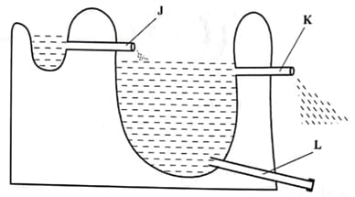
- The diagram shows a structure of a fish pond. Use it to answer the questions that follows.

  - Name the parts labelled: (2 marks)
    - J - ……………………………………………………………………………………………..
    - L - …………………………………………………………………………………………….
  - State why the parts labelled in (a) above are fitted with screens. (1 mark)
…………………………………………………………………………………………………………………………………………………………………………………………………………
  - Explain two maintenance practices carried in a fish pond. (2 marks)
………………………………………………………………………………………………………………………………………………………………………………………………………………………………………………………………………………………………………………
- A farmer wants to prepare 5000kg of chick mash containing 20% DCP, using maize grain (10% DCP) and fish meal (40% DCP). Using Pearson's Square method, calculate the quantity of maize and fish meal the farmer requires. (5 marks)
………………………………………………………………………………………………………………………………………………………………………………………………………………………………………………………………………………………………………………………………………………………………………………………………………………………………………………………………………………………………………………………………………………………………………………………………………………………………………………………………………………………………………………………………………………………………………………………………………………………………………………………………………………………………………………………………………………………………………………………………………………………………………………………………………………………………………………………………………………………………………………………………………………………………………………………………………………………………………………………………
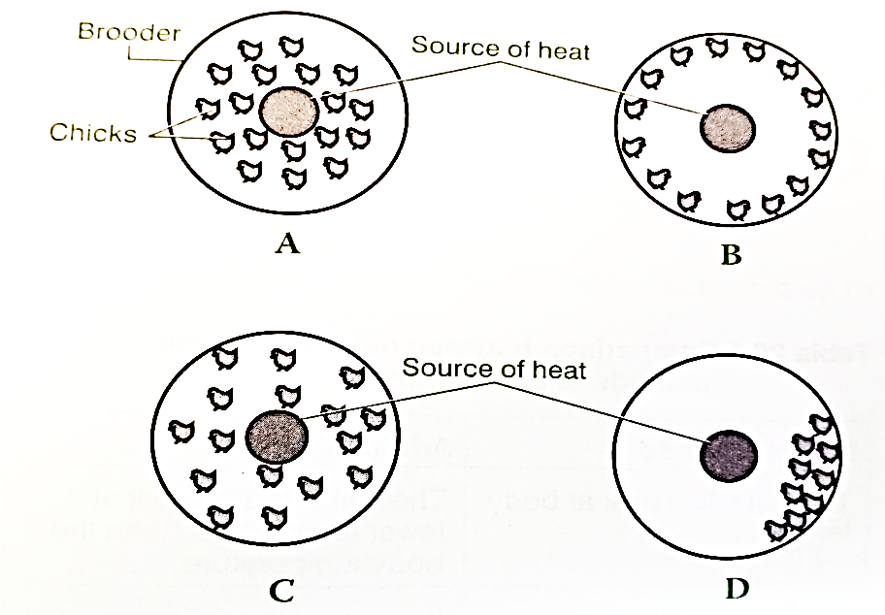
- Study the illustrations shown below and answer the questions that follow:
  - Explain the behavior of chicks in diagram B & D. (2 marks)
    - B - …………………………………………………………………………………………….
    - D - …………………………………………………………………………………………….
  - Give two reasons why dim lights are recommended in a brooder. (2 marks)
………………………………………………………………………………………………………………………………………………………………………………………………………………………………………………………………………………………………………………
  - Why is it necessary for the walls of a brooder to be circular in shape. (1 mark)
………………………………………………………………………………………………………………………………………………………………………………………………………………………………………………………………………………………………………………
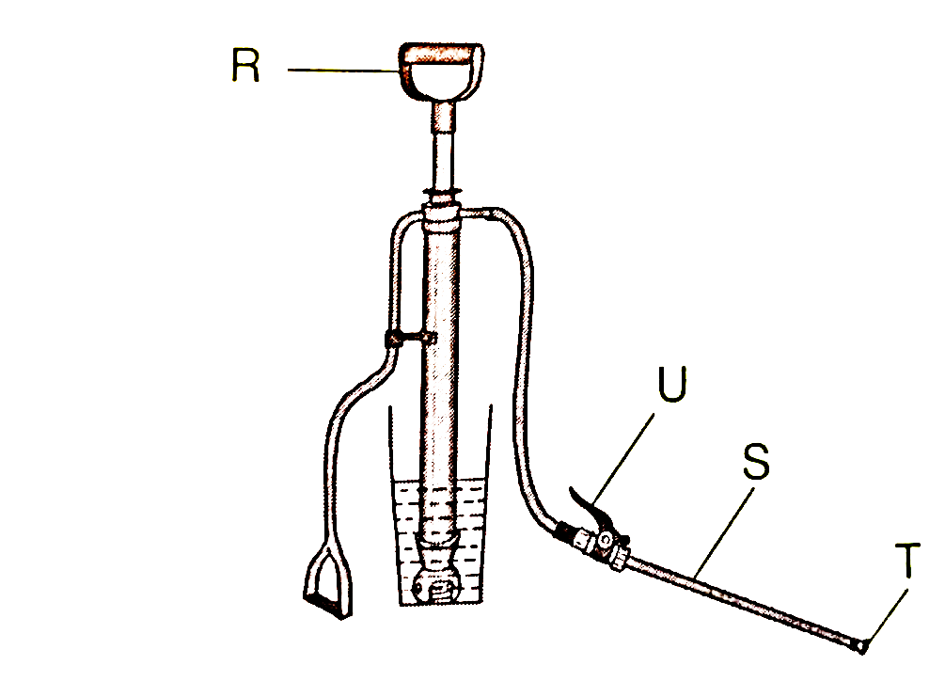
- The diagram shows a farm equipment. Study it and answer the questions that follow:
  - Name the parts labelled R, U, S and T. (2 marks)
…………………………………………………………………………………………………………………………………………………………………………………………………………………………………………………………………………………………………………………………………………………………………………………………………………………………………………………………………………………………………………………………
  - State two maintenance practices that should be carried out on the equipment illustrated above.
(2 marks)
………………………………………………………………………………………………………………………………………………………………………………………………………………………………………………………………………………………………………………
……………………………………………………………………………………………………
  - State one disadvantage of using the equipment above in controlling ticks. (1 mark)
…………………………………………………………………………………………………………………………………………………………………………………………………………
……………………………………………………………………………………………………

SECTION C (40 MARKS)
Answer any two questions from this section in the spaces provided after question 23.

- Give five reasons why Kenyan dairy farmers prefer artificial insemination in cattle breeding.
(5 marks)
- State five importance of keeping livestock healthy on the farm. (5 marks)
- Explain how the milking process should be handled to ensure clean milk production on the farm. (10 marks)

  - Describe the procedure of training a calf to take milk from a bucket in artificial calf rearing.
(5 marks)
  - Give reasons why indigenous cattle breeds are well adapted to arid areas. (5 marks)
  - Explain five ideal features of a calf pen. (10 marks)

  - Describe ten causes of low egg production in layers. (10 marks)
  - Discuss Foot and Mouth disease under the following sub-headings:
    - Causal organism. (1 mark)
    - Livestock species attacked. (2 marks)
    - Symptoms of attack. (4 marks)
    - Control measures. (3 marks)

………………………………………………………………………………………………………………………………………………………………………………………………………………………………………………………………………………………………………………………………………………………………………………………………………………………………………………………………………………………………………………………………………………………………………………………………………………………………………………………………………………………………………………………………………………………………………………………………………………………………………………………………………………………………………………………………………………………………………………………………………………………………………………………………………………………………………………………………………………………………………………………………………………………………………………………………………………………………………………………………
………………………………………………………………………………………………………………………………………………………………………………………………………………………………………………………………………………………………………………………………………………………………………………………………………………………………………………………………………………………………………………………………………………………………………………………………………………………………………………………………………………………………………………………………………………………………………………………………………………………………………………………………………………………………………………………………………………………………………………………………………………………………………………………………………………………………………………………………………………………………………………………………………………………………………………………………………………………………………………………………
………………………………………………………………………………………………………………………………………………………………………………………………………………………………………………………………………………………………………………………………………………………………………………………………………………………………………………………………………………………………………………………………………………………………………………………………………………………………………………………………………………………………………………………………………………………………………………………………………………………………………………………………………………………………………………………………………………………………………………………………………………………………………………………………………………………………………………………………………………………………………………………………………………………………………………………………………………………………………………………………
………………………………………………………………………………………………………………………………………………………………………………………………………………………………………………………………………………………………………………………………………………………………………………………………………………………………………………………………………………………………………………………………………………………………………………………………………………………………………………………………………………………………………………………………………………………………………………………………………………………………………………………………………………………………………………………………………………………………………………………………………………………………………………………………………………………………………………………………………………………………………………………………………………………………………………………………………………………………………………………………
………………………………………………………………………………………………………………………………………………………………………………………………………………………………………………………………………………………………………………………………………………………………………………………………………………………………………………………………………………………………………………………………………………………………………………………………………………………………………………………………………………………………………………………………………………………………………………………………………………………………………………………………………………………………………………………………………………………………………………………………………………………………………………………………………………………………………………………………………………………………………………………………………………………………………………………………………………………………………………………………
………………………………………………………………………………………………………………………………………………………………………………………………………………………………………………………………………………………………………………………………………………………………………………………………………………………………………………………………………………………………………………………………………………………………………………………………………………………………………………………………………………………………………………………………………………………………………………………………………………………………………………………………………………………………………………………………………………………………………………………………………………………………………………………………………………………………………………………………………………………………………………………………………………………………………………………………………………………………………………………………
………………………………………………………………………………………………………………………………………………………………………………………………………………………………………………………………………………………………………………………………………………………………………………………………………………………………………………………………………………………………………………………………………………………………………………………………………………………………………………………………………………………………………………………………………………………………………………………………………………………………………………………………………………………………………………………………………………………………………………………………………………………………………………………………………………………………………………………………………………………………………………………………………………………………………………………………………………………………………………………………
………………………………………………………………………………………………………………………………………………………………………………………………………………………………………………………………………………………………………………………………………………………………………………………………………………………………………………………………………………………………………………………………………………………………………………………………………………………………………………………………………………………………………………………………………………………………………………………………………………………………………………………………………………………………………………………………………………………………………………………………………………………………………………………………………………………………………………………………………………………………………………………………………………………………………………………………………………………………………………………………
………………………………………………………………………………………………………………………………………………………………………………………………………………………………………………………………………………………………………………………………………………………………………………………………………………………………………………………………………………………………………………………………………………………………………………………………………………………………………………………………………………………………………………………………………………………………………………………………………………………………………………………………………………………………………………………………………………………………………………………………………………………………………………………………………………………………………………………………………………………………………………………………………………………………………………………………………………………………………………………………
………………………………………………………………………………………………………………………………………………………………………………………………………………………………………………………………………………………………………………………………………………………………………………………………………………………………………………………………………………………………………………………………………………………………………………………………………………………………………………………………………………………………………………………………………………………………………………………………………………………………………………………………………………………………………………………………………………………………………………………………………………………………………………………………………………………………………………………………………………………………………………………………………………………………………………………………………………………………………………………………
………………………………………………………………………………………………………………………………………………………………………………………………………………………………………………………………………………………………………………………………………………………………………………………………………………………………………………………………………………………………………………………………………………………………………………………………………………………………………………………………………………………………………………………………………………………………………………………………………………………………………………………………………………………………………………………………………………………………………………………………………………………………………………………………………………………………………………………………………………………………………………………………………………………………………………………………………………………………………………………………
………………………………………………………………………………………………………………………………………………………………………………………………………………………………………………………………………………………………………………………………………………………………………………………………………………………………………………………………………………………………………………………………………………………………………………………………………………………………………………………………………………………………………………………………………………………………………………………………………………………………………………………………………………………………………………………………………………………………………………………………………………………………………………………………………………………………………………………………………………………………………………………………………………………………………………………………………………………………………………………………

