




MARANDA HIGH SCHOOL
Kenya Certificate of Secondary Education
THE MOCK EXAMINATIONS, 2026
231/2 BIOLOGY PAPER 2
May/JUNE 2026 Time: 2 Hours

MARKING GUIDE

231/2 © 2026The Maranda School Turn Over

​1. The diagram represents members of Kingdom Animalia:
​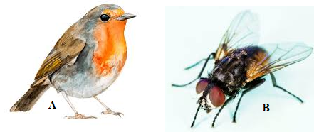
​(i) To which class of chordates does organism A belong? (1 mark)
​ Aves;
​ii) State two observable features to justify your identity in (i) above. (2 marks)
​ Presence of feathers for flight;
​Presence of a beak for feeding;
​Scales on legs;
​iii) How are the wings of organism A different from the wings of organism B? (2 marks)
A | B
Derived from the endoskeleton; | Derived from the exoskeleton;
used to push the body forward; | used to keep the body in the air;

​iv) Suggest the type of evolution exhibited between the wings of organism A and that of organism B. (1 mark)
​Convergent; (evolution)
​v) Apart from having a streamlined body, how are the following structures modified to enhance flight:
​(i) Sternum (1 mark)
​ Modified into a keel to increase surface area for attachment of flight muscles;
​(ii) Hind limbs / Bones: (1 mark)
​ Hollow to reduce weight for easier flight; / buoyancy.
​2. Students at Jakaranda Senior School carried out an experiment to investigate a physiological process in living organisms. Study the set-up used and answer the questions that follow:
​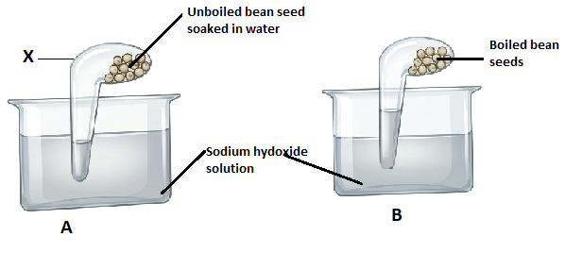
a) i) State the aim of the experiment. (1 mark)
​To find out if germinating seeds produce CO₂; / To find out CO₂ production by germinating seeds;
​ii) Name the apparatus labeled X. (1 mark)
​Retort flask;
​iii) Explain the convenience of the apparatus in this experiment. (1 mark)
​It is transparent, hence the level of liquid in it is easily seen;
​c) Explain the observation made in set up A. (2 marks)
The germinating seeds respired, giving out CO₂; which dissolves in NaOH solution, creating a vacuum in the flask; hence NaOH rises to occupy the space initially occupied by CO2.
​d) Comment on the importance of set up B in this experiment. (1 mark)
​It is a control experiment;
​e) State the adaptations of pneumatophores to gaseous exchange. (2 marks)
​Have lenticels to allow diffusion of gases;
​Have aerenchyma tissue that stores air and creates channels for air transportation to the tissues submerged deep in the mud;
​3. a) State three ways through which plants compensate for their inability to locomote. (3 marks)
Have flowers for pollination; leading to reproduction.
​Have roots for absorption of water and nutrients;
​Have leaves containing chlorophyll to enable the plant to carry out photosynthesis;
​b) Study the diagram
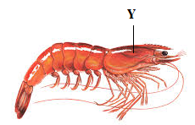
(i) Name the structure labelled Y. (1 mark)
​Carapace;
​ii) State three functions of structure Y. (3 marks)
​Provides a surface for muscle attachment;
​Protects inner delicate parts from mechanical damage;
​It is pigmented for camouflage;
In some for brooding by carrying young ones;
​In some, it provides buoyancy due to its air capturing properties;
​c) Name the type of skeleton that provides support for the organism in (b) above. (1 mark)
​Exoskeleton;
​4. During a court hearing involving two conflicting couples, it was noted that two children from their marriage were hemophiliac while the rest were normal. The man wanted a divorce claiming the wife was the cause of their children's disorder.
​a) Was the claim by the husband justified? (1 mark)
​Yes; /was justified;
​b) Give a reason for your response in (a) above. (1 mark)
​Haemophilia is a sex-linked trait linked to the X chromosome/Genes for haemophilia are carried on the X chromosome. Males are heterogametic (XY), hence their single X chromosome comes from the mother, while females are homogametic (XX) and can be carriers. Therefore, both parents contribute to the inheritance pattern, but a hemophiliac son inherits the allele specifically from the mother.
​c) State the genotypes of the couple. (2 marks)
​Man : X^{H}Y
​Woman : X^{H}X^{h}
​d) Using letter H for normal gene and h for recessive gene, work out the genotypes of the F1 generation. (4 marks)
​Parental Genotypes: X^H Y (Man) \times X^H X^h (Woman)
​Gametes: (X^H), (Y) \times (X^H), (X^h)
​F1 Genotypes: X^H X^H (Normal Female), X^H X^h , X^H Y , X^h Y .
​
5. The diagram below represents the pathway of water from the soil into the plant
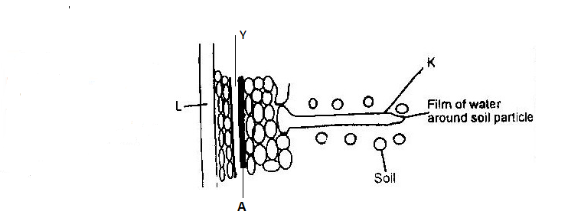
​a) Explain how water from the soil reaches the structure L. (3 marks)
​Water is absorbed by root hair K through osmosis; The cortical cells take in water from K cell by cell via osmosis; Water is then forced across the endodermis and passes through the pericycle Y into the xylem L;
​
b) Name the structure marked Y. (1 mark)
​Pericycle;
​c) State the physiological process involved in water movement across structure Y. (1 mark)
Osmosis;
​d) Students poured iodine solution around structure K. After 30 minutes, they made a cross section through region A. Parts of region A stained blue-black. Explain. (2 marks)
​Region A contains starch granules; which stain blue-black when they react with iodine solution;
​e) Name the substance in region A which makes it impermeable to water. (1 mark)
​Suberin;
​SECTION B
​6. The numbers of different types of animals supported by a square kilometer in two terrestrial ecosystems are shown in the table below:
Type of ecosystem | Type of animal | Number of animals supported per square km
Acacia/ Savanna | Domestic animals
Acacia/ Savanna | Cattle  Goats  Sheep | 7  30  10
Acacia/ Savanna | Wild animals | 450  20  60
Acacia/ Savanna | Thomson gazelles  Elland  Wild beasts | 450  20  60
Bushland | Domestic animals | 2  15  5
Bushland | Cattle  Goat  Sheep | 2  15  5
Bushland | Wild animals | 200  20  10
Bushland | Thomson gazelles  Elland  Wild beasts | 200  20  10

(i) Which domestic animal is better adapted to both ecosystems? (1 mark)
​Goat;
​(ii) Give a reason why the animal in (i) Above is better adapted to the two ecosystems. (1 mark)
​It is both a grazer and a browser;
​(b) (i) Why are cattle and sheep fewer in the bush land than in the savannah? (1 mark)
​Insufficient grass in the bushland; they are not adapted to eating twigs as they are grazers and not browsers;
​(c) (i) Name suitable methods that were used to estimate the population of domestic animals (1 mark):
Total count; / head count;/direct counting
​(ii) Give a reason why the method named for wild animals in c(i) above is suitable. (1 mark)
​fewer animals; / large animals in open areas;
​(d) State three methods which could be used to determine the diet of wild animals in an ecosystem. (3 marks)
​Study the dentition / beaks / claws / mouthparts;
​Analyse gut content;
​Observe it eating;
​Examine the faecal matter;
​Examine the structure of the digestive system;
(e) Name four biotic factors that could have regulated the animal population in both ecosystems.
​ (4 marks)
Diseases;
​Competition;
​Predation;
​Parasitism
​Human activity; (e.g., poaching, hunting).
Migration; acc Immigration / Emigration
​(f) State four human activities that affect populations of animals in game parks. (4 marks)
​Road construction within parks;
​Pollution;
​Poaching;
​Deforestation;
​Licensed game hunting;
Cropping;
​(g) What is the importance of national parks to a nation? (3 marks)
​Conserve animals from poaching;
Conserve wildlife and rare species;
​Tourism; (earns foreign exchange)
​Research centers;
​Protection of humans/crops from wild animals;
​(h) State one disadvantage of eutrophication. (1 mark)
​Inhibits penetration of light, hence decreasing primary productivity in water.
7. A grade ten student from Maranda High School took a meal of boiled maize. Describe the process of digestion that took place in his alimentary canal. (20 marks)
​Boiled maize was ingested; (through the mouth). In the mouth, it is chewed/masticated; (by teeth) to break it into smaller particles; then mixed with saliva; from salivary glands.
​Water; in the saliva will dissolve some food; while mucus; will lubricate it; Salivary amylase/ptyalin; will digest some starch in the food into maltose; The food is then rolled by the tongue into boluses; and pushed down into the oesophagus/swallowed;
​(Once swallowed), the bolus moves by peristalsis; into the stomach; through the cardiac sphincter; Constant contractions and relaxation of circular and longitudinal muscles of the stomach walls mix the food; (churning), giving rise to chyme; The presence of HCl in the stomach stops the action of salivary amylase and does not favor the digestion of starch; hence, the chyme/food is pushed into the duodenum; through the pyloric sphincter;
​Arrival of chyme in the duodenum stimulates cells on the duodenal wall; to secrete hormones: secretin; and cholecystokinin; Secretin stimulates the liver to secrete bile; while cholecystokinin stimulates the gall bladder to release bile juice; into the duodenum. The pancreas is also stimulated to secrete pancreatic juice which contains pancreatic amylase;
​Bile provides an alkaline medium; for pancreatic amylase to digest the remaining starch into maltose; The food is then pushed to the ileum; where it stimulates secretory cells in the inner walls of the ileum to secret succus entericus (intestinal juice); Succus entericus contains maltase; which digests maltose to glucose; Digestion of boiled maize is hence completed.
​ 30 marks. (max 20)
8. a) Explain the two main principles of Lamarck's theory of evolution. (6 marks)
​i) Use and disuse of structures; Continuous use of a particular structure in an organism over a long period of time leads to its enhanced development; while continuous disuse of a particular structure in an organism leads to its degeneration / becomes vestigial / rudimentary; (3 marks)
​ii) Environmentally acquired characteristics are inherited; Traits acquired by an individual from the environment during its lifetime are transmitted to their offspring; and subsequent generations, resulting in the emergence of new species; (3 marks)
​b) In Britain there are two species of moth i.e. Black melanic form and speckled white variety. The Black melanic form is predominantly found in urban areas while the speckled white variety is predominantly found in rural areas. Briefly explain this phenomenon of evolution. (14 marks)
​In rural areas, tree trunks are covered with lichens which are light in colour; The speckled white variety camouflages well with the bark of trees; they are not easily seen by predatory birds; and are not eaten; Hence, they survive to maturity and reproduce; giving rise to new species; Therefore, the white colour is an advantageous variation; that makes the speckled white variety selected for by nature; The black melanic form, however, is easily seen by predators; eaten, and hence their population decreases; The black colour here is a disadvantageous variation; hence, the black melanic form is not selected for.
​In urban areas; due to pollution, the lichens die, and tree trunks are covered with soot; The black melanic form camouflages well with the dark background; they are not easily seen;and are not eaten by predators; They survive to maturity and reproduce; forming more of the melanic form; The black colour becomes an advantageous variation; hence, the black melanic form is selected for by nature; The speckled white variety, however, is easily seen by predators and eaten; hence reducing their population; The white colour becomes a disadvantageous variation; therefore, it is not selected for by nature.
​
(18 marks, max 14)

