



MARANDA HIGH SCHOOL
Kenya Certificate of Secondary Education
THE MOCK EXAMINATIONS, 2026
233/1 CHEMISTRY PAPER 1

JUNE 2026 Time: 2 Hours

Name: …………………………………….……. Admission No: …………
Stream: ……………….. Signature: ………........Tuesday, 2ND June, 2026; 8:00-10.00Am
Instructions to Candidates
a) Write your name and Admission number in the spaces provided above.
b) Sign and write the date of examination in the spaces provided above
c)Answer ALL the questions in the spaces provided below each question.
d)Mathematical tables and silent electronic calculators may be used.
c)All working MUST be clearly shown where necessary.
e) This paper consists of 12 printed pages
FOR EXAMINERS’USE ONLY
1 | 2 | 3 | 4 | 5 | 6 | 7 | 8 | 9 | 10 | 11 | 12 | 13 | 14 | 15 | 16 | 17 | 18

19 | 20 | 21 | 22 | 23 | 24 | 25 | 26 | 27 |  | Grand Total
© 2026 The Maranda School
233/1 Turn Over
1.An extract colouring matter was placed at the centre of a filter paper and allowed to dry. Drops of ethanol were added to the centre and eventually the following was observed.
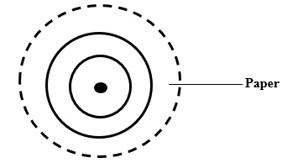
(a) Name a process by which dilute extract can be made more concentrated. (1mark)

……………………………………………………………………………………………………………..

(b) Give the name of the process by which the circles were produced. (1mark)

……………………………………………………………………………………………………………..

(c) Explain why water is not suitable for this process. (1mark)

……………………………………………………………………………………………………………..
……………………………………………………………………………………………………………..
2.The diagram below shows the Frasch process used for extraction of Sulphur. Use it to answer the questions that follow.
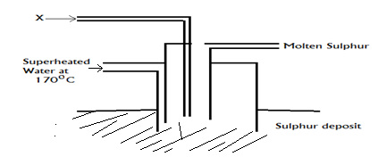
(a) Identify X (1 mark)
……………………………………………………………………………………………………………..
(b)Why is it necessary to use superheated water in this process? (1 mark)
……………………………………………………………………………………………………………..……………………………………………………………………………………………………………..
(c) Give two examples of non-crystalline allotropes of sulphur. (1 mark)
………………………………………………………………………………………………………………..…………………………………………………………………………………………………………
3.The flow chart below shows how nitric(V) acid can be obtained.
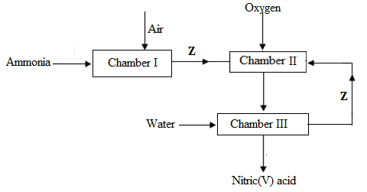
(a) Identify the chamber in which a catalyst is used and name the catalyst. (1 mark)
……………………………………………………………………………………………………………..
(b) Name substance Z. (1 mark)
……………………………………………………………………………………………………………
(c)Write an equation for the reaction that takes place in chamber III. (1 mark)
……………………………………………………………………………………………………………
4.Starting with 25cm³ of 0.2M potassium hydroxide solution, describe how you would prepare potassium sulphate crystals. (3marks)
………………………………………………………………………………………………………………..…………………………………………………………………………………………………………
……………………………………………………………………………………………………………………………………………………………………………………………………………………………………………………………………………………………………………………………………………………………………………………………………………………………………………………..

5.The apparatus shown below was used to investigate the products formed when concentrated sodium
chloride was electrolysed using inert electrodes.

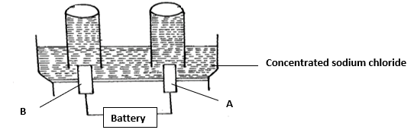
(a) Write equation of the reaction that takes place at electrodes A anode (1 mark)
……………………………………………………………………………………………………………..
(b) If the concentrated sodium chloride was replaced with dilute sodium chloride, what product would be formed at electrode A. Explain (2marks)
………………………………………………………………………………………………………………..…………………………………………………………………………………………………………
…………………………………………………………………………………………………………………………………………………………………………………………………………………………..
6. (a)Identify the substance that acts as acid. Give a reason. (2marks)
NH₄⁺(_{aq) +} H₂O_{(l)} NH_{3(g)} + H₃O⁺ _{(aq)}
………………………………………………………………………………………………………………………………………………………………………………………………………………………………………………………………………………………………………………………………………..
b) Name the particle responsible for conduction of electricity in the following.
i) Magnesium sulphate solution ( ½mark)
……………………………………………………………………………………………………………
ii) Mercury ( ½mark)
……………………………………………………………………………………………………………
7. Two cleansing agents are represented below.
COO⁻Na⁺ OSO⁻₃Na⁺
Detergent P Detergent R

a) Classify the detergents above. (2marks)
…………………………………………………………………………………………………………………………………………………………………………………………………………………………
b) Select one of the detergents that would not be suitable for washing in water containing magnesium chloride. Explain. (1mark)
…………………………………………………………………………………………………………………………………………………………………………………………………………………………
8. Name the homologous series to which of the following belongs to: (2marks)
a) CnH2n+2
……………………………………………………………………………………………………………
b) CnH2n -2
……………………………………………………………………………………………………………
c) Ethane can be prepared by use sodium propanoate and soda lime, write the equation for the reaction taking place. (1mark)
……………………………………………………………………………………………………………
9. a) Magnesium reacts with air to produce two solids, Name the solids. (2marks)
…………………………………………………………………………………………………………………………………………………………………………………………………………………………

b) Cold water reacts slowly with a piece of magnesium to produce bubbles of hydrogen gas. Write the equation for the reaction between cold water and magnesium (1mark)
……………………………………………………………………………………………………………

10.A student measured the pH values of solutions A, B,C,D and E and obtained the following results.
Solution | pH Value
A | 1.0
B | 5.0
C | 13.0
D | 8.0
E | 7
a) Which of the solution is likely to be;
i) Magnesium chloride. (1 mark)
……………………………………………………………………………………………………………..
ii) Acetic acid. (1 mark)
……………………………………………………………………………………………………………..
b) Identify the solution which can react with Beryllium oxide. (1 mark)
……………………………………………………………………………………………………………..
11.Element U has atomic number 12 while element V has atomic number 16. How do the melting points of their oxides compare? Explain. (3 marks)
……………………………………………………………………………………………………………
…………………………………………………………………………………………………………..…
………………………………………………………………………………………………………….…
…………………………………………………………………………………………………………..…
12. 1.0g of an alloy of aluminium and copper was reacted with excess dilute hydrochloric acid. 840cm³ of hydrogen gas was produced at s.t.p. calculate the percentage of copper in the alloy. (Al =27, molar gas volume = 22400cm³ ) (3 marks)
……………………………………………………………………………………………………………
…………………………………………………………………………………………………………..…
………………………………………………………………………………………………………….…
…………………………………………………………………………………………………………..…

13. Given that;
Zn²⁺_{(aq)} + 2e- Zn_{(s)} E° = -0.76V
Sn²⁺ _{(aq)} + 2e- Sn_{(s)} E°= - 0.14V
Cu²⁺ _{(aq)} + 2e- Cu_{(s)} E°= +0.34V
Can a solution of zinc chloride be stored in a tin container? Show your working. (3 marks)

……………………………………………………………………………………………………………
…………………………………………………………………………………………………………..…
………………………………………………………………………………………………………….…
…………………………………………………………………………………………………………..…
14. Starting with zinc powder, describe how you would obtain a sample of solid zinc carbonate.
(3 marks) ..................................................................................................................................................................... ..................................................................................................................................................................... ..................................................................................................................................................................... ..................................................................................................................................................................... .....................................................................................................................................................................
15.The diagram below shows an attempt to prepare dry hydrogen gas, a class set-up the experiment below

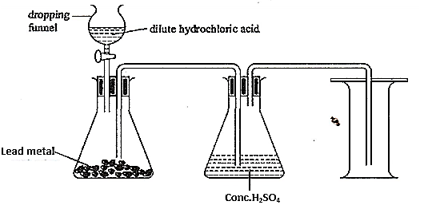
a) Identify two mistakes in the set-up (2 marks)
……………………………………………………………………………………………………………
…………………………………………………………………………………………………………..…
………………………………………………………………………………………………………….…
b) Describe the test that would be used to completely identify the presence of hydrogen gas (1 mark)
……………………………………………………………………………………………………………
…………………………………………………………………………………………………………..…
16.The control rod in a nuclear reactor are made of boron, natural boron contains about 20% ( ${}_{\text{5}}^{\text{10}}{\text{ B}}$ ) and 80% boron ( ${}_{\text{5}}^{\text{11}}{\text{ B}}$ )
a) Draw the atomic structure of ( ${}_{\text{5}}^{\text{11}}{\text{ B}}$ ) (1 mark)
……………………………………………………………………………………………………………
…………………………………………………………………………………………………………..…
………………………………………………………………………………………………………….…
…………………………………………………………………………………………………………..…
b) Calculate R.A.M of boron (2 marks)
……………………………………………………………………………………………………………
…………………………………………………………………………………………………………..…
………………………………………………………………………………………………………….…
…………………………………………………………………………………………………………..…
17. (a) State Gay Lussac’s Law. (1mark) ……………………………………………………………………………………………………………..
…………………………………………………………………………………………………………..…
………………………………………………………………………………………………………….…
(b). In an experiment, 436cm³ of hydrogen sulphide was exploded in 363cm³ of oxygen and reacted as per the following equation.
2H₂S_{(g)} + 3O_{2(g)} 2SO₂ + 2H₂O
Determine the volume of the residual gas. (2marks) …………………………………………………………………………………………………………………………………………………………………………………………………………………………..
…………………………………………………………………………………………………………..…
………………………………………………………………………………………………………….…
…………………………………………………………………………………………………………..…
18. 3.1g of an organic compound containing Carbon, hydrogen and oxygen only produced 4.4g of Carbon (IV) oxide and 2.0g of water on complete combustion.
(a) Calculate its empirical formula. (2 marks) ……………………………………………………………………………………………………………
…………………………………………………………………………………………………………..…
………………………………………………………………………………………………………….…
…………………………………………………………………………………………………………..…
…………………………………………………………………………………………………………………………………………………………………………………………………………………………..

(b) Calculate the molecular formula if its formula mass is 62. (1 mark) ……………………………………………………………………………………………………………
…………………………………………………………………………………………………………..…
………………………………………………………………………………………………………….…
19. The curves below were obtained when equal volumes of HCl acid of same concentration were reacted with 25.0g of Mabel chips. In one case, the acid was first warmed to a high temperature.
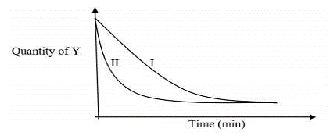
(a) Which curve represents the reaction involving warm hydrochloric acid? (1 mark) ……………………………………………………………………………………………………………..
(b) Suppose a graph of volume of CO₂ produced against time was plotted, draw on the same axes a sketch to show the graphs of the reaction above and label them as warm acid and cold acid. (2 marks)

20. When copper (II) sulphate solution was reacted with barium chloride solution the molar enthalpy was found to be – 18kJ/mole. Calculate the temperature change if 600cm³ of 1M copper (II) sulphate was added to 400cm³ of 1M barium chloride solution. ( S.H.C = 4.2J/g/k, density of mixture = 1g/cm³ )
(3marks)
……………………………………………………………………………………………………………
…………………………………………………………………………………………………………..…
………………………………………………………………………………………………………….…
…………………………………………………………………………………………………………..…
……………………………………………………………………………………………………………
…………………………………………………………………………………………………………..…21. a) Name the two common ores from which Zinc metal can be extracted. (1 mark)
……………………………………………………………………………………………………………
…………………………………………………………………………………………………………..…
………………………………………………………………………………………………………….…b) Taking one of the ores named in (a) above, write a chemical equation for the roasting process to get the required oxide. (1 mark)
……………………………………………………………………………………………………………
(c) Outline any two uses of Zinc metal. (1 mark)
……………………………………………………………………………………………………………
…………………………………………………………………………………………………………..…
………………………………………………………………………………………………………….…
22. Chlorine gas was bubbled through potassium iodide solution.
a) State the observation that would be made. (1 mark) ……………………………………………………………………………………………………………
…………………………………………………………………………………………………………..…
b) Write the ionic equation for the reaction that took place in (a) above. (1 mark) …………………………………………………………………………………………………………….. ……………………………………………………………………………………………………………
c) Identify the oxidizing agent in the ionic equation (b) above. (1 mark)

……………………………………………………………………………………………………………..

23. In the Haber process, the optimum yield of ammonia is obtained when a temperature of 450⁰C, pressure of 200 atmospheres and an iron catalyst are used. Equation for the reaction is shown below.
N_{2(g)} + 3H_{2(g)} ) $⇌$ 2NH_{3(g)} Δ H= -92kJ.
How the yield of ammonia would be affected if:
i) Temperature raised to 600⁰C (1 mark) ……………………………………………………………………………………………………………
…………………………………………………………………………………………………………..…

ii) Pressure raised to 250 atmospheres. (1 mark) ……………………………………………………………………………………………………………
…………………………………………………………………………………………………………..…
iii) The amount of catalyst doubled (1 mark)
……………………………………………………………………………………………………………
…………………………………………………………………………………………………………..…

24. Methane reacts with bromine as shown in the following equation.
CH_{4(g)} + Br_{2(g)} CH₃B_{r(g)} + HBr_{(g)}
Using the bond energies in the table below, calculate the enthalpy change ∆H, for the reaction (3marks)
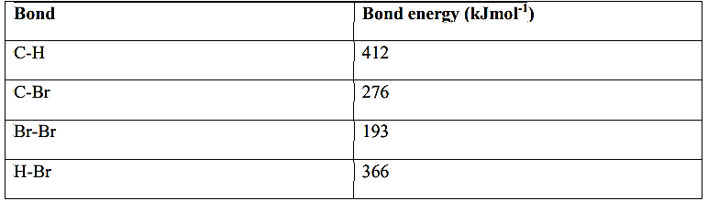
……………………………………………………………………………………………………………
…………………………………………………………………………………………………………..…
………………………………………………………………………………………………………….…
…………………………………………………………………………………………………………..…
25. Zinc reacts with both concentrated and dilute sulphuric (VI) acid. Write the equations for the two reactions (2marks)
……………………………………………………………………………………………………………
…………………………………………………………………………………………………………..…
………………………………………………………………………………………………………….…
…………………………………………………………………………………………………………..…

26. A current of 0.75A was passed through 300cm³ of 0.5M Copper (II) sulphate solution. Determine the time taken in seconds to deposit all the copper in the solution at the cathode. (Cu = 63.5, 1F = 96500 Coulombs) (3marks)
……………………………………………………………………………………………………………
…………………………………………………………………………………………………………..…
………………………………………………………………………………………………………….…
…………………………………………………………………………………………………………..…
……………………………………………………………………………………………………………
…………………………………………………………………………………………………………..…
27. Consider the two nuclear reactions shown below Equation
I: ${}_{\text{92}}^{\text{235}}{\text{ U}}$+${}_{\text{0}}^{\text{1}}{\text{ n}}$ ${}_{\text{56}}^{\text{140}}{\text{ B}}a$+${}_{\text{36}}^{\text{92}}{\text{ Kr}}$+ 3 ${}_{\text{0}}^{\text{1}}{\text{ n}}$

II: ${}_{\text{1}}^{\text{3}}{\text{ H}}$ + ${}_{\text{1}}^{\text{2}}{\text{ H }}$ ${}_{\text{2}}^{\text{4}}{\text{ He}}$ + ${}_{\text{0}}^{\text{1}}{\text{ n}}$
a) Name the type of reaction represented by equation (II). (1mark) ……………………………………………………………………………………………………………..
b) State two similarities between the reactions in the two reactions (1mark) ………………………………………………………………………………………………………………………………………………………………………………………………………………………………………………………………………………………………………………………………………..
c) A radioactive substance emits alpha, beta and gamma particles. Explain why alpha particles are said to have highest ionizing power (1mark)
…………………………………………………………………………………………………………………………………………………………………………………………………………………………

THIS IS THE LAST PRINTED PAGE

