



MARANDA HIGH SCHOOL
Kenya Certificate of Secondary Education
THE MOCK EXAMINATIONS, 2026
233/2 CHEMISTRY PAPER 2

JUNE 2026 Time: 2 Hours
Name: …………………………………….……. Admission No: …………
Stream: ……………….. Signature: ………......... Monday, 8th June, 2026; 11:00-1.00pm
Instructions
- Write your name, admission number, stream and signature in the spaces provided above.
- All answers must be written in the spaces provided in the booklet.
- This paper consists of 13 printed pages with 7 questions. Candidates should check the question paper to ascertain that all the pages are printed as indicated and that no questions are missing
- Candidate should answer the questions in English
FOR EXAMINERS USE ONLY
Questions | Maximum Score | Candidate’s Score
1 | 12
2 | 12
3 | 13
4 | 12
5 | 11
6 | 12
7 | 08
TOTAL | 80
© 2026 The Maranda School
233/2 Turn Over
1. The grid below represents part of the periodic table. Study it and answer the question that follows. (Letters do not represent the actual symbols of the elements).
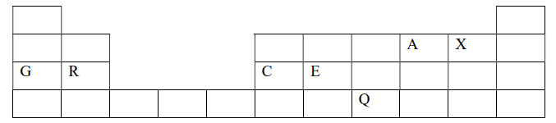
a) (i) How does the atomic size of C and E compare? Explain. (1 mark) ………………………………………………………………………………………………………………………………………………………………………………………………………………………………………………………………………………………………………………………………………………..
(ii) Write an equation for the reaction between G and A. (1 mark) ……………………………………………………………………………………………………………..………………………………………………………………………………………………………………......
(iii) How do the pH of the chlorides G and C compare? Give a reason for your answer (2 marks) ………………………………………………………………………………………………………………………………………………………………………………………………………………………………………………………………………………………………………………………………………………..
(iv) State the observation made when the chloride of R is exposed to air. (1 mark) ………………………………………………………………………………………………………………………………………………………………………………………………………………………………
b) (i) On the grid indicate with a tick (√) the position of the element Z which is the third. found on the period and forms Z ³⁻ ions. (1 mark)

ii) Using dots (.) and crosses (X) to represent outermost electrons, show how bonding in the compound formed when R and A react. (1 mark)
………………………………………………………………………………………………………………………………………………………………………………………………………………………………………………………………………………………………………………………………………………..
………………………………………………………………………………………………………………..
c) Study the information in the table below and use it to answer the questions that follow. (Letters do not represent the actual symbols of the elements)
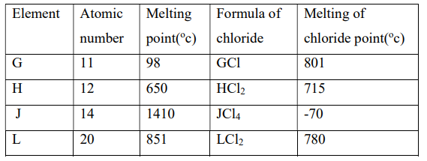
(i) Which elements are metals? Give a reason (2 marks) ………………………………………………………………………………………………………………………………………………………………………………………………………………………………..
(ii) What is the oxidation state of J in its chloride? (1 mark) ………………………………………………………………………………………………………………………………………………………………………………………………………………………………..
(iii) How does the reactivity of H and L with water compare? Explain. (2 marks)
………………………………………………………………………………………………………………………………………………………………………………………………………………………………………………………………………………………………………………………………………………..

2. (I) Give the systematic names of the following compounds.
(i) CH₃CH₂COOH …………………………………………………………………………………(1 mark)
(ii) CH₃COOCH₂CH₃ ………………………………………………………………….…………. (1 mark)
(iii) CHCCH₂CH₃ ………………………………………………………………………………… (1 mark)
II) The scheme below shows a series of reactions starting with ethanol. Study it and answer the questions that follow:

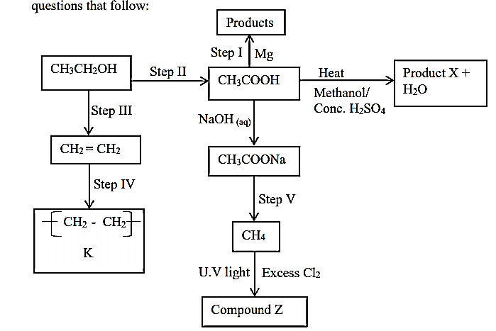

(a) Name the types of reactions, reagents and conditions in steps:-
(i) Step II
Name ……………………………………………. Reagents ………..………………………… (1½ marks)
Condition ……………………………………………………………………………………………………
(ii) Step III
Name …………………………………………….. Reagents …………….…………………… (1½ marks)
Condition ………………………………………………..…………………………………………………
(b) Write the equation for the reaction that take place in step I (1 mark) ……………………………………………………………………………………………………….
……………………………………………………………………………………………………….
(c) Name the product X (1 mark) ……………………………………………………………………………………………………….
(d) Identify the process leading to the formation of compound Z (1 mark) ………………………………………………………………………………………………………………………………………………………………………………………………………………………………
(e) Name compound K and state one of its uses. (2 marks) ………………………………………………………………………………………………………………………………………………………………………………………………………………………………
(f) If the RMM of K is 39,200. Determine the value of n. (1 mark)
……………………………………………………………………………………………………….
……………………………………………………………………………………………………….
……………………………………………………………………………………………………….
……………………………………………………………………………………………………….
3.a) Draw a well labelled diagram to show how zinc metal is purified by electrolysis. (2marks)
……………………………………………………………………………………………………….
……………………………………………………………………………………………………….
……………………………………………………………………………………………………….
……………………………………………………………………………………………………….
……………………………………………………………………………………………………….
Reaction | Eº(V)
MnO⁻_{4 (aq)} + 8H⁺ _{(aq)} + 5e⁻ Mn²⁺ _{(aq)} + 4H₂O_{(l)} | +1.44
M³⁺_{(aq)} + e⁻ M²⁺_{(aq)} | +077
A²⁺_{(aq)} + 2e⁻ A_{(s)} | +0.34
P²⁺_{(aq)} + 2e⁻ P_{(s)} | -0.23
T_{2(g)} + 2e⁻ 2T⁻_{(aq)} | +2.86
b) Use the standard electrode potentials given below to answer the questions that follows
c) i) State whether acidified MnO⁻_{4 (aq)} can oxidise M²⁺. Give a reason for your answer. (2marks)
……………………………………………………………………………………………………….
……………………………………………………………………………………………………….
ii) Write the e.m.f of the half-cell of A if P was used as a reference electrode. Show working. (1mark)
……………………………………………………………………………………………………….
………………………………………………………………………………………………………
iii) Select two half cells which would produce the highest e.m.f when combined (1mark)
……………………………………………………………………………………………………….
d) Draw a well labelled diagram of the electrochemical cell formed when the half cells named above are combined. (3marks)
……………………………………………………………………………………………………….
……………………………………………………………………………………………………….
……………………………………………………………………………………………………….
………………………………………………………………………………………………………
e) i) Calculate the e.m.f of the electrochemical cell above. (2marks)
……………………………………………………………………………………………………….
……………………………………………………………………………………………………….
ii) An alloy containing iron was dissolved in an acid and the total volume made up to 250cm³.25cm³ of this solution required 18.0cm³ of 0.15M acidified potassium dichromate VI to react with completely as shown Cr₂O₇²⁻ _{(aq)} + 14H⁺ _{(aq)} + 6Fe²⁺ 2Cr³⁺ _{(aq)} +6Fe³⁺ 7H₂O_{(l)}
Calculate the mass of iron in the alloy. (Fe=56) (2marks)
……………………………………………………………………………………………………….
……………………………………………………………………………………………………….
……………………………………………………………………………………………………….
……………………………………………………………………………………………………….
……………………………………………………………………………………………………….
4. a) What is meant by molar heat of neutralization (1 mark)
……………………………………………………………………………………………………….
……………………………………………………………………………………………………….
……………………………………………………………………………………………………….
b) In an experiment to determine the molar heat of neutralization,50.0 cm³of 1M hydrochloric acid was neutralized by adding 10cm³ portion of dilute sodium hydroxide. During an experiment, the data in the table below was obtained.
Volume of sodium hydroxide (cm³) | 0 | 10 | 20 | 30 | 40 | 50 | 60
Temperature of the mixture(⁰C) | 25.0 | 27.0 | 29.0 | 31.0 | 31.0 | 30.0 | 29.0
i) On the grid provided, plot a graph of temperature(y-axis) against volume of sodium hydroxide(x-axis) added (3 marks)

b) Using the graph:
I) Determine the volume of sodium hydroxide which completely neutralize 50cm³ of 1M hydrochloric acid. (1 mark)
………………………………………………………………………………………………………
………………………………………………………………………………………………………
II) Determine the change in temperature$ΔT$ when complete neutralization occurred (1 mark)

………………………………………………………………………………………………………
III) Calculate.
i) The heat change, when complete neutralization occurred.
(Specific heat capacity=4.2J/g/K, density of solution =1g/cm³) (2 marks)
………………………………………………………………………………………………………
……………………………………………………………………………………………………….
………………………………………………………………………………………………………
ii) Molar heat of neutralization of hydrochloric acid with sodium hydroxide (2 marks)
………………………………………………………………………………………………………………………………………………………………………………………………………………
………………………………………………………………………………………………………
iii) Draw an energy level diagram for the reaction that occurred (2 marks)

iv) How would the value of molar heat differ if 50cm³ of 1M ethanoic acid was used instead of 1M hydrochloric acid? Give a reason (1 mark)
………………………………………………………………………………………………………………………………………………………………………………………………………………
5.The flow chart below shows how a fertilizer can be manufactured. Use it to answer the questions that follow.
H₂ N₂ Air SO₂
P
Catalyst D: 450⁰C
R
Catalyst C; 450⁰C, high pressure

98% Conc.H₂SO4

S
Reaction vessel Q
Enough water
I(a) Name catalyst C and catalyst D.
(1 mark)
C …………………………………………………………………………………………………….
D ……………………………………………………………………………………………………. (b) Give the identities of substance: (2 marks)
P …………………………………………………………………………………………………….
S …………………………………………………………………………………………………….
R …………………………………………………………………………………………………….
(c) Give the identity of the fertilizer formed. (½ mark)
……………………………………………………………………………………………………….
(d) Write an equation for the reaction at vessel Q. (1 mark)
……………………………………………………………………………………………………….
……………………………………………………………………………………………………….
(e) Explain why substance R is absorbed in 98% sulphuric (VI) acid first before adding water. (1 mark)
……………………………………………………………………………………………………….
……………………………………………………………………………………….………………
(f) Name one methods by which pollution is controlled in contact process. (½ mark)
……………………………………………………………………………………………………….
……………………………………………………………………………………………………….
……………………………………………………………………………………………………….
………………………………………………………………………………………………………
II (a)When hydrogen sulphide gas was bubbled into an aqueous solution of Iron (III)
chloride, a yellow precipitate was deposited.
State another observation that was made. (1 mark)
……………………………………………………………………………………………………….
……………………………………………………………………………………………………….
(b) Write an equation for the reaction that took place. (1 mark)

……………………………………………………………………………………………………….
(c) Explain why old newspapers slowly change to brown when exposed to air and sunlight. (1 mark)
……………………………………………………………………………………………………….
……………………………………………………………………………………………………….
……………………………………………………………………………………………………….
(d) Describe a chemical test that can be used to distinguish sodium sulphate and sodium sulphite. (2 marks)
……………………………………………………………………………………………………….
……………………………………………………………………………………………………….
……………………………………………………………………………………………………….
………………………………………………………………………………………………………
……………………………………………………………………………………………………….
6. I Study the flow chart below and answer the questions that follow.
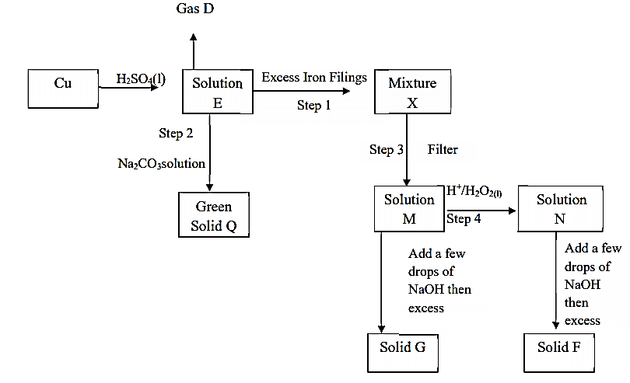
(i) Name the following substances. (2 marks)
Solution E…………………………………….………. Green solid Q…………...…………………………
Solid F …………………………………………...……Solution M …………..…………………………….
(ii) State and explain the observation made at step 4. (2 marks) ……………………………………………………………………………………………………….
……………………………………………………………………………………………………….
(iii) Name the reaction that takes place at step 2. (1 mark) ……………………………………………………………………………………………………….
……………………………………………………………………………………………………….
(iv) Draw a well labeled set up to show how mixture X is separated. (2 marks)

(v) Write chemical equation to represent the formation of solid G. (1 mark) ……………………………………………………………………………………………………….
……………………………………………………………………………………………………….
(vi) Explain what happens if Sulphur (IV) oxide gas was bubbled through solution N (1 mark) ……………………………………………………………………………………………………….
……………………………………………………………………………………………………….
II .8.08g of sodium chloride solution at 25℃ was reacted with excess Lead (II) nitrate. After filtration, washing and drying 4.8g of Lead (II) chloride was obtained. Determine the solubility sodium chloride at 25℃ (Na =23, Pb = 207, Cl = 35.5) (3 marks)
……………………………………………………………………………………………………….
……………………………………………………………………………………………………….
……………………………………………………………………………………………………….
……………………………………………………………………………………………………….
7. A form four student wanted to prepare carbon (IV) oxide gas. The diagram below is part of the set up.
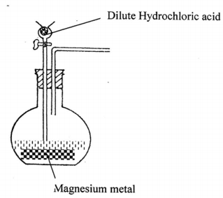
(a) Identify two mistakes in the set up (2 marks) ……………………………………………………………………………………………………….
……………………………………………………………………………………………………….
……………………………………………………………………………………………………….
……………………………………………………………………………………………………….
(b) Complete the set up showing how a sample of dry carbon (IV) oxide can be collected. (2 marks)
(c) Write an ionic equation for the above reaction if the mistakes are corrected (1 mark) ……………………………………………………………………………………………………….
……………………………………………………………………………………………………….
(d) State and explain what is observed when a piece of burning magnesium is dipped in a gas jar
full of carbon (IV) oxide. (2 marks) ……………………………………………………………………………………………………….
……………………………………………………………………………………………………….
……………………………………………………………………………………………………….
(e) (i) During Manufacture of sodium carbonate in Solvay process it is said to be the most efficient
process. State one factor that makes it efficient. (1 mark) ……………………………………………………………………………………………………….
……………………………………………………………………………………………………….
(ii) Explain why potassium carbonate cannot be manufactured through Solvay process. (1 mark) ……………………………………………………………………………………………………….
……………………………………………………………………………………………………….
(iii) State one use of sodium carbonate (1 mark) ……………………………………………………………………………………………………….
……………………………………………………………………………………………………….

THIS IS THE LAST PRINTED PAGE

